**Development of**

**Journal Management System**

**For Uttara Info Tech**

A Practicum Report Submitted By

**Mohammad Tamim Rahman**

ID # 16103369

In Partial Fulfillment of the Requirements for the Award of

Bachelor of Computer Science and Engineering



**Department of Computer Science and Engineering**

College of Engineering and Technology

**Summer 2020**

# Development of Online Journal Management System for DORP

Md. Tamim Rahman

ID#16103369

A practicum report submitted in partial fulfillment of the requirements for the degree of Bachelor of Computer Science and Engineering (BCSE)

The practicum has been examined and approved,

______________________________

Prof Dr Md Abdul Haque

Chairman

Dept. of Computer Science and Engineering

IUBAT – International University of Business

Agriculture and Technology

______________________________

Prof Dr. Utpal Kanti Das

Coordinator

Dept. of Computer Science and Engineering

IUBAT – International University of Business Agriculture and Technology

______________________________

MD Sakibul Islam

Lecturer

Dept. of Computer Science and Engineering

IUBAT – International University of Business Agriculture and Technology

**Department of Computer Science and Engineering**

**College of Engineering and Technology**

IUBAT – International University of Business Agriculture and Technology

**Summer 2020**

## Letter of Transmittal

7th October, 2020

To

The Chairman, Practicum and Placement Board

College of Engineering and Technology - CEAT

IUBAT - International University of Business Agriculture and Technology

4 Embankment Drive Road, Sector - 10 Uttara Model Town, Dhaka-1230, Bangladesh

Subject: **Letter of Transmittal.**

Sir,

With due respect, I would like to approach you that it is a great opportunity as well as immense pleasure for me to submit this report titled “ Journal Management System” for the fulfillment of my Practicum course.

It was undoubtedly a splendid opportunity for me to work on this project to actualize my theoretical knowledge and has an enormous exposure with the corporate culture of a renowned company. Now I am looking forward for your kind appraisal regarding this practicum report.

I shall remain deeply grateful to you if you kindly go through this report and evaluate my performance.

Thanking you

__________________

Mohammad Tamim Rahman

ID# 16103369

Program: BCSE

# Letter of Authorization

**7th October, 2020**

IUBAT- International University of Business Agriculture and Technology

4, Embankment Drive Road, Uttara Model Town

Sector 10, Dhaka -1230, Bangladesh.

**Sub: Letter of Authorization**

Dear Tamim Rahman,

You will be happy to know that project on “**Development of Journal Management System**”. I have received your proposal under my continue internship. Based on your proposal you will have to submit it as soon as possible. I hope you will successfully complete the project on time. After successful completion of the project, you are requested to write a report based on the project.

For any kind of needs don’t hesitate to contact with me.

|  |  |  |
| --- | --- | --- |
| Co-supervisor  **Prof. Dr. Utpal Kanti Das**  Coordinator,  Department of Computer Science and  Engineering |  | Supervisor  **Md Sakibul Islam**  Lecturer,    Department of Computer Science and  Engineering |

# Student’s Declaration

I am Mohammad Tamim Rahman, student of BCSE - Bachelor of Computer Science and Engineering program, under the College of Engineering and Technology (CEAT) of IUBAT- International University of Business Agriculture and Technology declaring that, this report on the topic of

―Development of Online Event Management System for Uttara Tech Info has been prepared for the fulfillment of the internship CSC 490, Practicum as well as the partial requirement of BCSE-Bachelor of Computer Science and Engineering degree.

The report and the project on ―Development of Journal Management System for Uttara Tech Info are originally prepared by me. All module and procedure of this project is being made after proper inspection and internet information.

It has not been prepared for any other purposes, rewards or presentations.

……………………….

Mohammad Tamim Rahman

ID #16103369

Program: BCSE

## Supervisor’s Certification

This is to certify that Practicum report on **“Development of Journal Management System for DORP”** has been carried out by Mohammad Tamim Rahman bearing ID# 16103369, of IUBAT – International University of Business Agriculture and Technology as a partial fulfillment of the requirement of practicum defense course. The report has been prepared under my guidance and is a record of the accomplished work carried out successfully. To the best of my knowledge and as per his declaration, no parts of this report has been submitted anywhere for any degree, diploma or certification.

Now he is permitted to submit the report. I wish him success in all his future endeavors.

Practicum Supervisor

----------------------------------------

Md. Sakibul Islam

Lecturer

Department of Computer Science and Engineering

IUBAT- International University of Business Agriculture and Technology

# Departmental Declaration

On behalf of the Department of Computer Science and Engineering of International University of Business Agriculture and Technology (IUBAT University) we, the undersigned, certify that this practicum report “Journal Management System” for the award of Bachelor of Computer Science and Engineering (BCSE) degree was duly presented by Mohammad Tamim Rahman (ID No. 16103369) and accepted by the department.

**_______________________________**

Prof Dr. Md Abdul Haque

Chairman and Professor

Dept. of Computer Science and Engineering

IUBAT – International University of Business

Agriculture and Technology

_______________________________

Prof Dr. Utpal Kanti Das

Coordinator

Dept. of Computer Science and Engineering

IUBAT – International University of Business

Agriculture and Technology

_______________________________

Md Sakibul Islam

Lecturar

Dept. of Computer Science and Engineering

IUBAT – International University of Business

Agriculture and Technology

## Acknowledgement

In the name of ALLAH, In the Name of Allah, the Most Beneficent, the Most Merciful.

It's my pleasure to take this occasion to thank a few people, who have, assisted, encouraged, directed and supported me throughout my practicum program.

First of all, I want to thank my parents, who have endowed their immeasurable-innumerable support and encouragement to attain this exquisite event of my life.

My sincere thanks to our **Vice Chancellor Dr. Abdur Rab** to give me an opportunity to submit this report.

My outmost and sincere gratitude goes to **Prof. Dr. Utpal Kanti Das**, Coordinator of Department of Computer Science and Engineering, IUBAT-International University of Business Agriculture and Technology for allowing me to work on the project.

I would like to pay my gratitude to my faculty advisor **Md Sakibul Islam**, Lecturer of Computer Science & Engineering Department, who has given me the opportunity to make such a report for not only in this semester but also throughout my education life at IUBAT- International University of Business Agriculture and Technology by giving her valuable suggestions and advices at any time, at any situation. I would able to make this report effectively and properly only for her right direction.

Their continuous encouragement and contribution gave me the courage and determination needed to complete the internship and project properly.

## Abstract

The report is for practicum defense. The primary objective of this report is to learn how to conduct a project and work in real field, and write it down in a formal and specific way. The secondary objective of this report is to learn about how this Journal Management System can manage publications for the authors easily. The Journal Management System is developed for providing the publication services ability to publish research papers without facing any problem. There are four types of user in this system including admin, authors, reviewer and publisher. Admin can handle authors and publisher information. Admin can approve or reject authors and publishers profile. Publisher can approve or reject reviewer information. Author can submit a paper and can see the result after review. Publisher can assign paper to reviewer for review. After getting the paper reviewer review the paper and submit it. Then after seen the review, publisher decide this paper should publish or not. Publisher also make the category of the paper. We provide free registration for the authors. The objective of this system is to make the journal management system easy, reliable, user friendly, and corrective. The main objective of this system is to automate the publication process, feedback systems, paper uploading’s, reviewer review and so on. I have plans to implement other features in future. At the end of the day, what I can say is I put our honest effort and hard work to implement the system as efficient as possible. I wish to make it flawless in near future.

Table of Contents

Development of Online Journal Management System for DORP ii

Letter of Transmittal iii

Letter of Authorization iv

Student’s Declaration v

Supervisor’s Certification vi

Departmental Declaration vii

Acknowledgement viii

Abstract ix

Chapter 1: Organizational Overview 15

1.1 Organizational Overview 16

1.2 Organizational Services 16

1.3 Organizational Location 16

1.4 The Vision 16

1.5 The Mission 17

1.6 Software Developer Intern 17

1.7 Organization Structure 17

Chapter 2: Project View 18

2.1 Introduction 19

2.2 Project Overview 19

2.3 Background of Study 19

2.4 Objectives 20

2.4.1 Broad Objective 20

The general objective of this project is to use my institutional educational experience in the real life-working environment by developing Online Journal Management System for Uttara Tech Info. 20

2.4.2 Specific Objective 20

• View Paper Information 20

• Upload Papers 20

• Get feedback from reviewer 20

• Re uploading the papers 20

• Provide feedbacks on papers 20

• View paper pdf 20

• Manage Publications 20

• Manage Registration 20

• Information 20

2.5 Proposed System 20

2.6 Methodology 20

2.6.1 Data Sources 21

2.7 Limitation of the Project 21

2.8 Process Model 21

Figure 2.1: Incremental Process Model 22

2.8.1 Reason for choosing the Incremental Process model 22

2.9 Feasibility Study 22

2.9.1 Technical feasibility 22

2.9.2 Economic feasibility 23

2.9.3 Operational feasibility 23

Chapter 3: Requirement Engineering 24

3.1 Requirement Analysis 25

3.2 Requirements Engineering 25

3.2.1 User Requirements 25

3.2.2 System Requirements 26

3.2.3 Functional Requirements: 28

3.2.4 Non-Functional Requirements: 29

3 Use Case Diagram 29

Figure 3.1: Use case diagram 29

3.3.1 Use Case Text 30

Chapter 4: System Planning 32

4.1 System Project Planning 33

4.2.1 System Project Estimation 33

4.2.2 Function Oriented Metrics 33

4.3 Internal Logical File 35

Table 4.1 : Internal Logical File(ILF) 35

4.4 External Input 35

Table 4.2 : External Input 35

4.5 External Output 36

Table 4.3: External output 36

4.6 Transaction Function 36

Table 4.4: Transaction Function 36

4.7 Data Function 39

Table 4.4 : Data Function 39

Table-4. 5: Performance and Environmental Impact 40

4.8 Process Based Estimation 41

Table-4.6: Process Based Estimation 41

4.9 Effort Based Estimation 42

Figure 4.2: Project Schedule Chart 43

4.10 Cost Estimation 43

Table-4. 7: Personal Cost 44

**4.2.7.1 Hardware Cost** 44

Table-4. 8: Hardware cost 44

**4.2.7.2 Software Cost** 44

Table-4. 9: Software Cost 45

**4.2.7.3 Other Cost** 45

Table-4. 10: Other cost 45

**4.2.7.4 Accounts Table** 45

Table-4. 11: Total cost 45

Chapter 5: Risk Engineering 46

5.1 Risk Analysis 47

5.2 Risk analysis 47

5.3 The RMMM Plan 48

Table-5. 1: Project Risk (P01) 49

Table-5. 2 Project Risk (P02) 49

Table-5. 3: Project Risk (P03) 50

Table-5. 4: Project Risk (P04) 50

Table-5.5: Technical Risk (TR01) 51

Table-5.6: Technical Risk (TR02) 51

Table-5.6: Technical Risk (TR03) 52

Table-5.7: Business Risk (B01) 52

Table-5.8: Business Risk (B02) 53

Table-5.9: Business Risk (B03) 53

Table-5.10: Business Risk (B04) 54

Chapter 6: Analysis Modeling 55

6.1 Analysis Modeling 56

6.2 Activity Diagram 56

6.2.1 Activity diagram for Admin 57

Figure 6.1: Activity diagram for Admin 57

6.2.2 Activity diagram for Author 58

Figure 6.2: Activity diagram for Admin 58

6.2.3 Activity diagram for Publisher 59

Figure 6.3: Activity diagram for Admin 59

6.2.4 Activity diagram for Reviewer 60

Figure 6.4: Activity diagram for Admin 60

6.3 Swim lane Diagram 61

6.3.1 Swim Lane Diagram for Journal Management System 61

Figure 6.5: Swim Lane diagram for Journal Management System 61

6.4 Entity Relationship Diagram 62

6.4.1 ER Diagram 62

Figure 6.6: ER Diagram of Journal Management System 62

6.5 Data Flow Diagram 63

6.5.1: Context Level Diagram 63

Figure 6.7: Context Level 0 Diagram of Journal Management System 63

6.5.2: Level 1 DFD 64

Figure 6.8: Level 1 for System 64

6.5.3: Level 2 DFD Process 1 64

Figure 6.9: Level 2. 64

6.5.4:Level 2 DFD Process 2 65

Figure 6.10: Level 2.2 65

6.5.5: Level 2 DFD Process 3 66

Figure 6.11: Level 2.3 66

6.5.6: Level 2 DFD Process 4 66

Figure 6.12: Level 2.4 66

6.5.7: Level 3 DFD Process 1.2 67

Figure 6.13: Level 3, Process 1.2 67

6.5.8: Level 3 DFD Process 2.6 67

Figure 6.14: Level 3, Process 2.6 67

6.5.9: Level 3 DFD Process 4.2 68

Figure 6.15: Level 3, Process 4.2 68

Chapter 7: Design 69

7.1 Database Design 70

Figure 7.1: Database Tables 70

Figure 7.2: User Table 70

Figure 7.3: Manuscript Table 70

Figure 7.4: Category Table 70

7.2 Interface Design 70

Figure 7.5: Interface 71

Figure 7.6: Registration Page 72

Figure 7.6: Registration Page 72

Figure 7.7: Admin Page 73

Figure 7.8: Create Manuscript Page 73

Figure 7.9: Publisher Page 74

Figure 7.10: Reviewer Page 74

Chapter 8: System Testing 75

8.1 System Testing 76

8.1.1 Software Testing Strategy 77

8.2 System Testing Methodology 78

Table-8. 1: Testing Scenario No-1 79

Table-8.2: Testing Scenario No-2 80

Table-8.3: Testing Scenario No-3 80

Table-8.4: Testing Scenario No-4 81

Table-8.5: Testing Scenario No-5 81

Chapter 9: Conclusion 83

9.1 Preface 84

9.1.1 Practicum and Its Value 84

9.2 Limitations 85

9.3 Future Plan 85

9.4 Conclusion: 85

References 86

# 

# Chapter 1: Organizational Overview

# 1.1 Organizational Overview

Uttara InfoTech (UIT) is a leading Website Design and Software Development company in Uttara, Dhaka, Bangladesh. We are engaged in Business ERP Solution software development for Group of company, Garments Industry, Hospital, School & College, T V media, NGO, Telecom Industry, Real Estate, POS/Super Shop, Accessories companies etc. We also supply security devices, attendance devices and other IT Support as per company requirements. Already we served thousands of national and international clients in this field. We have one of the best creative team in the industry to provide the best IT solution within affordable cost. UIT also provide Web Application Development, Web Hosting, Domain Registration, Brand SMS Marketing, Social Media Marketing, Search Engine Marketing, Outsourcing Training and other Corporate IT support around the world.

# 1.2 Organizational Services

* Web Design
* Software Development
* Ecommerce Solution
* Outsourcing Training
* Domain Registration
* SMS Marketing
* Web Hosting

# 

# 1.3 Organizational Location

BNS Center (5th floor)

Room No. # 610, Sector # 07,

Uttara Model Town, Dhaka-1230,

Bangladesh.

# 1.4 The Vision

Uttara Tech Info is a growing IT company having a vision to be at the cutting edge of technology and to become a key player in the field of Software Development, IT Training and Systems, Bulk SMS, Domain and Hosting, Networking Solutions. We have a team of highly skilled and successful technical as well as management experts with us, who can deliver unmatched business value to customer through a combination of process excellence, quality frameworks, and service delivery innovation and in delivering technology-driven business solutions that meet the strategic objectives and that create solutions around specific needs of industries.

# 1.5 The Mission

The mission of Uttara Tech Info is to provide the community with the most innovative, state-of-threat, and comprehensive communications, information technology, and software system solutions through a highly motivated, creative, experienced, and talented team of professionals contributing to the success and satisfaction of the industries and customers we serve. Our training division will offer a wide range of career and professional courses in the field of Telecommunication, Software, Web development and Networking. These courses will help us to shape the trainees as a specialist with in-depth and concept driven and skill development program. We will ensure a professional excellence in everything we do and promote high standards of business ethics and long-term growth and stability through the process of delivering the best and being the best in our approach.

# 1.6 Software Developer Intern

At Uttara tech Info, I have worked as an intern with a software developer team. Here they offer fully integrated software development and technical support solutions. Uttara Tech Info is well-experienced custom software Development Company and software outsourcing company. We have great expertise in the development of custom software applications due to our professional team efforts in performing the work according to the need of our offshore clients. We strive to focus on the customer and deliver solutions designed around their requirements rather than focusing on a specific technology and expecting the customer to adapt to the technology and platform of our choice. We use to fulfill specific needs of our clients as per their convenience for their business.

# 1.7 Organization Structure

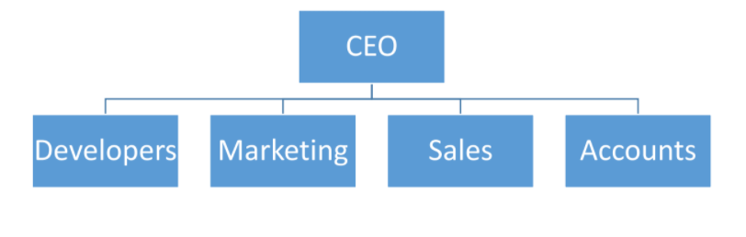

# 

# Chapter 2: Project View

# 

# 2.1 Introduction

Internship is a practical experience of theoretically gained knowledge and can measure as a groundwork trial to be aware with any organization and to make oneself confident enough to enter into service life and start building career. And wonderful and effective way to connect academic experience with the professional work arena. It allows gaining valuable experience to the workplace, provides the opportunity for skill development, and gives a competitive edge in the job search. This chapter attempts to describe the objectives, scope and all topics of initialization period of this project.

# 2.2 Project Overview

Journal Management System is a Web based application that works within a centralized network. This project presents a review on the software program **Journal Management System** as should be used in a publication system, a facility which is used to upload papers, receiving after paper has been reviewed by reviewer, publishing papers based on reviewer feedback. JMS is built for managing and computerizing the traditional database, reserved for publications. It maintains all author details, reviewer details and publications details. The Project named as **“Development of Online Journal Management System for Uttara Tech Info”**. It is a web based and database based application. This report based on internship, I completed this project at Uttara Tech info . In this report, I will describe how we developed this system and how it will work.

# 2.3 Background of Study

Today we can see different types of management software to manage our everyday tasks smoothly and perfectly. The company where I have done my intern is concerned about the making a publication platform & document management software. Therefore, for this reason I have chosen to develop Online Journal Management System for this company. Because currently, staffs are using different types of platforms that are costly & inconvenient. To solve each problem in a standard way I have decided to do the journal Management System, so that they can have a platform where they can publish their works free of charge.

# 2.4 Objectives

## 2.4.1 Broad Objective

### The general objective of this project is to use my institutional educational experience in the real life-working environment by developing Online Journal Management System for Uttara Tech Info.

## 2.4.2 Specific Objective

## View Paper Information

## Upload Papers

* Assign paper to reviewer

## Get feedback from reviewer

## Re uploading the papers

## Provide feedbacks on papers

## View paper pdf

## Manage Publications

## Manage Registration

## Information

* Add and Update, Authors, reviewer and publisher information
* Manage paper categories
* Search contents based on the given information

# 2.5 Proposed System

This journal Management System is an online system and all data is centralized which has overcome the Sharing problem in previous system. We provide free registration for the users. And we proved services to users who want to publish a paper. As data is maintained online, it is easy for a person to update the details, which has overcome the tedious updating in previous system. journal management is easy and performance is good. Here the author can upload a paper by inserting from a form along with other information’s, according to selected category. It is the reliable service provided to both authors and publishing agencies.

# 2.6 Methodology

The development process on ―Journal Management system for Uttara Tech info, through Incremental Model will complete following the structure described later on Software Analysis & Design. This study on ―Journal Management system for Uttara Tech Info, through Incremental Model is tentative in nature. It aims to development of management System. The variables identified to manipulate through a handy inspection and from primary and secondary data

## 2.6.1 Data Sources

For this project in data collection phase I collected two types of data

* Primary Data
* Secondary Data

**Primary** data are generated within the publication agencies. The publication agencies practical experience and observation helped me to generate the primary data.

**Secondary** data are generated by studying different articles, newspapers, research papers and of course information collected via Internet. Data, facts and statistics collected from different web sites and sources made us understand the project better.

# 2.7 Limitation of the Project

As I had mentioned early in this report that practicum is the bridge between theoretical and practical life, practicum program at IUBAT has given me this great opportunity to see how theories are put into action. In my case, there were lots of terms, conditions and systems that were not understandable for us at the beginning of my organizational attachment; however, lately I made myself familiar with those terms. So far, I have learned seeing my senior classmates and friends, they had experienced the same during their time as well. One of the limitations of this internship project is constraints of time. After applying the software engineering procedures, it is very difficult to develop the complete software within short time.

For this reason, the scope of the internship project has become short.

# 2.8 Process Model

In my project, I am using the Incremental Model. Incremental Model is a process of software development where requirements are broken down into multiple standalone modules of software development cycle.

Each iteration passes through the **requirements, design, coding and testing phases**. And each subsequent release of the system adds function to the previous release until all designed functionality has been implemented. That’s why I am chosen this type of process Model.

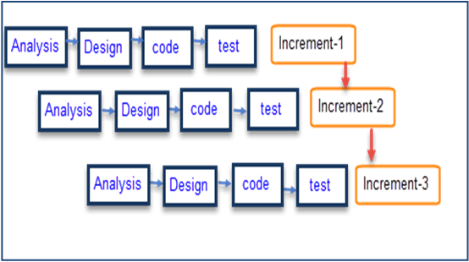

## Figure 2.1: Incremental Process Model

## 2.8.1 Reason for choosing the Incremental Process model

* In this model user can respond to each built.
* Lowers initial delivery cost.
* Software will be generated quickly during the software life cycle.
* It is flexible and less expensive to change requirements and scope.
* Thought the development stages changes can be done.
* Errors are easy to be identified.
* Generates working software quickly and early during the software life cycle

# 2.9 Feasibility Study

Feasibility study determines whether that solution is feasible or achievable for the organization.

There are three major areas of feasibility study.

* Technical feasibility
* Economic feasibility
* Operational feasibility

## 2.9.1 Technical feasibility

The technical feasibility assessment is focused on gaining an understanding of the present technical resources of the organization and their applicability to the expected needs of the proposed system. It is an evaluation of the hardware and software and how it meets the need of the proposed system

|  |  |  |
| --- | --- | --- |
| SN | Hardware Requirement | Software Requirement |
| 1. | Computer (Desktop/Laptop/Equivalent) | Operating System (Windows 10 or  equivalent) with browser (Google Chrome/Firefox) |
| 2. | Proper electricity Support | Php (Laravel) |
| 3. | Adequate system memory and secondary  Memory | MySQL |

**Communication Interface**

* Client on Internet will be using HTTP/HTTPS protocol.
* Client on Internet will be using TCP/IP protocol.

## 2.9.2 Economic feasibility

The purpose of the economic feasibility assessment is to determine the positive economic benefits to the organization that the proposed system will provide. My system is economically feasible because by using the proposed system many works can be done within small time and which is not possible by man power within the same time. It also reduces the man power needed for providing the Available Tickets Information, Bus Routes Information, booking tickets according to the date & time wise and generating report. So, Bus agencies have to payless salary where the current system needs many stuffs and they are paying much salary. So, I can say that, if they use proposed system, they will be economical.

## 2.9.3 Operational feasibility

User can easily operate the proposed system because the system is user friendly. It‘s easy to get transport routes information and easily book tickets according to the demands and also cancel the booked tickets within required time by contact with the agent. If the stuff of the organization has the basic to computer knowledge they could operate and manage the software easily. Every feature and the activity that I combined within the system is designed and developed belongs to previous format they had used with a more attractive user interface.

# 

# Chapter 3: Requirement Engineering

# 3.1 Requirement Analysis

Requirement analysis provides the software designer with a representation of information, function and behavior that can be translated to data, architectural, interface and component level designs. In the following task phases the requirement analysis was done.

# 3.2 Requirements Engineering

Requirements engineering is, as its name suggests, the engineering discipline of establishing user requirements and specifying software systems. There are many definitions of Requirements Engineering; however, they all share the idea that requirementsinvolves finding out what people want from a computer system, and understanding what their needs mean in terms of design. Requirements engineering is closely related to software engineering, which focuses more on the process of designing the system that users want.

* User requirements
* System requirements
* Functional requirements
* Non-Functional requirements
* Specification for each requirement

## 3.2.1 User Requirements

Admin:

* Admin can approve author and publisher
* Admin can reject author and publisher
* Admin can view author and publisher information
* Admin can delete individual author and publisher
* Admin can search individual author and publisher

Publisher:

* Publisher can add new reviewer
* Publisher can see reviewer information
* Publisher can search individual reviewer
* Publisher can assign a paper to reviewer
* Publisher can see the assigned paper
* Publisher can see the reviewed paper
* Publisher can approve or reject a reviewed paper
* Publisher can see the approved paper
* Publisher can create a manuscript list

Reviewer:

* Reviewer can view paper pdf
* Reviewer can view paper information
* Reviewer can give feedback after paper review
* Reviewer can download the papers

Author:

* Authors can upload paper
* Authors can choose paper category
* Author can add Co-Authors
* Author will be notified when the paper is under revision
* Author will be notified when the paper is published
* Author can see the judge feedbacks
* Author can manage paper information.

## 3.2.2 System Requirements

1. Admin can approve or reject author and publisher
   * First, admin will login into the system.
   * Check whether it is admin or not.
   * When new user come admin can approve or reject their profile

1. Admin can view author and publisher information
   * First of all, admin will login into the system
   * Check whether it is admin or not
   * Admin can view users information by clicking on Users Information
2. Admin can delete individual user information

* First of all, admin will login into the system.
  + - * Check whether it is admin or not.
      * Admin will select the added user information individually and click on **Delete** option.

1. Publisher can approve or reject reviewer information
   * First, publisher will login into the system.
   * Check whether it is publisher or not.
   * When new reviewer come admin can approve or reject their profile
2. Publisher can view reviewer information
   * First of all, Publisher will login into the system
   * Check whether it is publisher or not
   * Publisher can view reviewer information by clicking on Users Information

1. Publisher can delete individual reviewer information

* First of all, Publisher will login into the system.
  + - * Check whether it is Publisher or not.
      * Publisher will select the added user information individually and click on **Delete** option.

1. Publisher can search reviewer information

* First of all, Publisher will login into the system.
  + Check whether it is Publisher or not.
  + If Publisher click on **search** option, system will show individual users info

1. Publisher can see manuscript
   * When a manuscript come, publisher can see it.

1. Publisher can assign reviewer
   * Publisher can assign a manuscript to reviewer
2. Publisher can publish a manuscript
   * After reviewed manuscript come to publisher.
   * Publisher take decision it will approve or not
3. Reviewer can view a assigned manuscript
   * First of all, reviewer will login into the system
   * Check whether it is reviewer or not
   * He can view the assigned manuscript
4. Reviewer can review assigned paper
   * First of all, Publisher will login into the system
   * Check whether it is publisher or not
   * He can review the paper
5. Author can create
   * First of all, Author will login into the system
   * Check whether it is author or not
   * Author can create a new manuscript
6. Author can view the published manuscript
   * First of all, Author will login into the system
   * Check whether it is author or not
   * He can check his manuscript published or reject

## 3.2.3 Functional Requirements:

1. Admin can approve or reject publisher and author
2. Admin can add, view & delete publisher and author
3. Admin can search individual publisher and author
4. Publisher can approve or reject reviewer
5. Publisher can search individual reviewer
6. Publisher can assign a manuscript to reviewer
7. Publisher can see the reviewed manuscript
8. Publisher can publish papers based on the feedbacks from reviewer
9. Reviewer can receive papers based on the category assigned to them
10. Reviewer can give feedbacks after viewing the paper
11. Reviewer can see the approved manuscript
12. Author can create a manuscript
13. Authors can receive message after the reviewer have reviewed
14. Authors can receive messages after the publisher has published the paper
15. Author can upload paper.
16. Author can add co-authors
17. Author can view the feedbacks

## 

## 3.2.4 Non-Functional Requirements:

1. Admin can log in by using email and password.
2. Author can log in by using email and password.
3. Judge can log in by using email and password.
4. This system support only Windows 7/8/10

# 3 Use Case Diagram

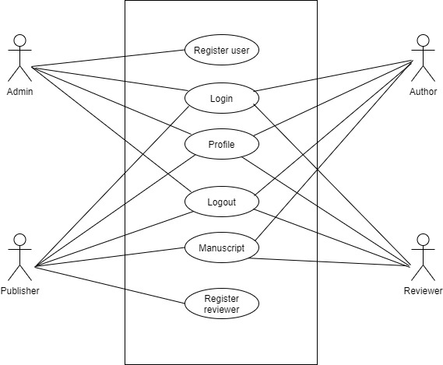

## Figure 3.1: Use case diagram

## 3.3.1 Use Case Text

**User Title: Registration User**

**Actor: Admin**

Description:

For being admin, admin can approve the register user.

**User Title: Login**

**Actor: Admin, Author, Publisher, Reviewer**

Description:

As an admin, I can login with a valid email& password. If I enter wrong email or password then system will show an error message.

As an author, I can login with a valid email& password. If I enter wrong email or password then system will show an error message

As an publisher, I can login with a valid email& password. If I enter wrong email or password then system will show an error message.

As an reviewer, I can login with a valid email& password. If I enter wrong email or password then system will show an error message.

**User Title: Profile**

**Actor: Admin, Author, Publisher, Reviewer**

Description:

As an admin, author, publisher, reviewer I can view and update my profile.

**User Title: Logout**

**Actor: Admin, Author, Publisher, Reviewer**

Description:

As an admin, author, publisher, reviewer I can log out.

**User Title: Manuscript**

**Actor: Author, Publisher, Reviewer**

Description:

As an author, I can upload a manuscript and see the manuscript after it reviewed

As a publisher, I can assign a manuscript to reviewer, I can accept or reject reviewed manuscript, and I can see the approved manuscript

As a reviewer, I can review a manuscript and submit it

**User Title: Register reviewer**

**Actor: Publisher**

Description:

For being publisher, admin can approve the register reviewer.

# Chapter 4: System Planning

# 4.1 System Project Planning

Before starting any project, it is compulsory to estimate the work to be done, the resources that will be required, the time that will elapse from start to finish and to analyze the project to determine whether it is feasible or not.

The following activities of software project planning that have followed in this project are:

* System Project Estimation
* Function Oriented Metrics
* Process Based Estimation
* Effort Distribution
* Task Scheduling
* Project Schedule Chart
* Cost Estimation

## 4.2.1 System Project Estimation

The accuracy of a software project estimate predicated based on a number of things:

* Properly estimated the size of the product to build.
* The ability to translate the size estimation into human effort, calendar time and money.
* The degree to which the project plan reflects the abilities of the software team or engineer.
* The stability of the product requirements and the environment that supports the software engineering effort.

Software size estimation is the most important matter that I have to consider during the software project. If the software size not calculate properly, then this will cause various problems such as scheduling problems, budget problem etc. As the project goes on before estimating the software size, I have to confirm that software scope is bounded.

## 4.2.2 Function Oriented Metrics

Function point-based estimation focuses on information domain values rather that software values. Function points are computed by comparing five information domain characteristics. The information domain values are as follows

**Number of external inputs (EI)** – Each user input that provides distinct application-oriented data to the software is counted inputs should be distinguished from inquires.

**Number of external outputs (EO)** – Each user output that provides application-oriented information to the user is counted.

**Number of external inquires (EQ)** – An inquiry defined as an on-line input those results in the generation of some immediate software response in the form of an on-line output. Each distinct inquiry counted.

**Number of Internal logical files (ILF) –** Each logical master file counted. Database table where from input goes for modified by application.

**Numbers of external interfaces files (EIF)** – All machine-readable interfaces that used to transmit information to another system counted.

The weights of the domains are fixes, which are provided in appropriate table location. Weights can be divided into three categories according to the functionality of the system. They are simple, average and complex. The total system is a complex system but the part of the total system. Once these data has collected, a complexity value is associated with each count. To find out the FP count the following formula is used,

Value Adjustment Factor (VAF) = (0.65+ (.01X TDI)) UFP = UFP (Data Fn) + UFP (Transaction Fn) Adjusted Function Point Count (AFP) = UFP X VAF Effort for PHP = AFP x Productivity

# 4.3 Internal Logical File

## Table 4.1 : Internal Logical File(ILF)

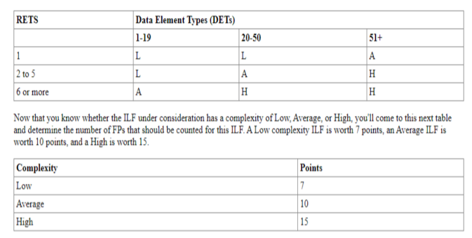

# 4.4 External Input

## Table 4.2 : External Input

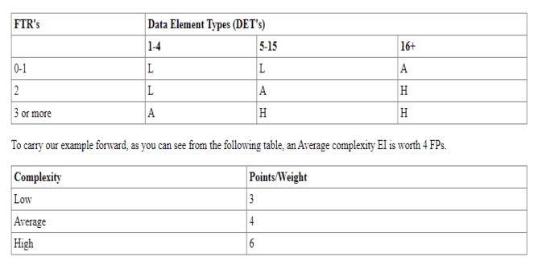

# 4.5 External Output

## Table 4.3: External output

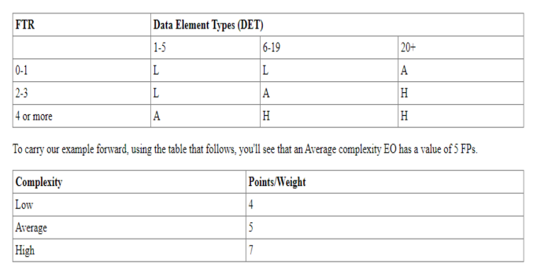

# 4.6 Transaction Function

## Table 4.4: Transaction Function

|  |  |  |  |  |  |
| --- | --- | --- | --- | --- | --- |
| **Data Functions** | **Fields** | **RETs** | **DETs** | **Complexity** | **UFP** |
| Display(EQ) | Fields: name, status  Files: Category  Fields: author_id, category_id, country_id, title,name,email,  summary,  paper,status  Files: Manuscripts  Fields: reviewer_id, manuscript_id,status,qus1, qus2, qus3, qus4,ques5,comment  Files: Reviewer_manuscript  Fields: first_name, last_name,name,  email,image,country  ,city,address,mobile,  about,designation,  password,user_type_id,  status  Files: User | **4** | **34** | **HIGH(H)** | **6** |
| Add(EI) | Fields: name, status  Files: Category  Fields: author_id, category_id, country_id, title,name,email,  summary,  paper,status  Files: Manuscripts  Fields: reviewer_id, manuscript_id,status,qus1, qus2, qus3, qus4,ques5,comment  Files: Reviewer_manuscript  Fields: first_name, last_name,name,  email,image,country  ,city,address,mobile,  about,designation,  password,user_type_id,  status  Files: User | **4** | **34** | **HIGH(H)** | **6** |
| Delete(EI) | Fields: name, status  Files: Category  Fields: author_id, category_id, country_id, title,name,email,  summary,  paper,status  Files: Manuscripts  Fields: reviewer_id, manuscript_id,status,qus1, qus2, qus3, qus4,ques5,comment  Files: Reviewer_manuscript  Fields: first_name, last_name,name,  email,image,country  ,city,address,mobile,  about,designation,  password,user_type_id,  status  Files: User | **4** | **34** | **HIGH(H)** | **6** |
| Update(EI) | Fields: name, status  Files: Category  Fields: author_id, category_id, country_id, title,name,email,  summary,  paper,status  Files: Manuscripts  Fields: reviewer_id, manuscript_id,status,qus1, qus2, qus3, qus4,ques5,comment  Files: Reviewer_manuscript  Fields: first_name, last_name,name,  email,image,country  ,city,address,mobile,  about,designation,  password,user_type_id,  status  Files: User | **4** | **34** | **HIGH(H)** | **6** |
| Search(EQ) | Fields: name, status  Files: Category  Fields: author_id, category_id, country_id, title,name,email,  summary,  paper,status  Files: Manuscripts  Fields: reviewer_id, manuscript_id,status,qus1, qus2, qus3, qus4,ques5,comment  Files: Reviewer_manuscript  Fields: first_name, last_name,name,  email,image,country  ,city,address,mobile,  about,designation,  password,user_type_id,  status  Files: User | **4** | **34** | **HIGH(H)** | **6** |
| **Total** | | | | | **30** |

# 4.7 Data Function

## Table 4.4 : Data Function

|  |  |  |  |  |  |
| --- | --- | --- | --- | --- | --- |
| **Data Functions** | **Fields** | **RETs** | **DETs** | **Complexity** | **UFP** |
| Category(ILF) | Fields: name, status | 1 | 2 | Low(L) | 7 |
| Manuscripts(ILF) | Fields: author_id, category_id, country_id, title,name,email,  summary,  paper,status | 1 | 9 | Low(L) | 7 |
| Reviewer_manuscript(ILF) | Fields: reviewer_id, manuscript_id,status,qus1, qus2, qus3, qus4,ques5,comment | 1 | 9 | Low(L) | 7 |
| User(ILF) | Fields: first_name, last_name,name,  email,image,country  ,city,address,mobile,  about,designation,  password,user_type_id,  status | 1 | 14 | Low(L) | 7 |
| Password_reset(ILF) | Fields:  Email,token | 1 | 2 | Low(L) | 7 |
| Total | | | | | 35 |

## Table-4. 5: Performance and Environmental Impact

|  |  |  |
| --- | --- | --- |
|  | **GSC** | **TDI** |
|  | Data Communication | 2 |
| 2 | Distributed Data Processing | 0 |
| 3 | Performance | 3 |
| 4 | Heavily Used Configuration | 1 |
| 5 | Transaction Rate | 0 |
| 6 | Online Data Entry | 3 |
| 7 | End-user Efficiency | 3 |
| 8 | Online Update | 2 |
| 9 | Complex Processing | 1 |
| 10 | Reusability | 3 |
| 11 | Installation Ease | 3 |
| 12 | Operational Ease | 3 |
| 13 | Multiple Sites | 3 |
| 14 | Facilitate Change | 3 |
| **Total Degree of Influence (TDI**)  (Range 0 to 70->influence size by +-35%) | | 30 |

Value Adjustment Factor (VAF) = (0.65+ (0.01×30)) = 0.99 = 1

UFP=(Data Function)+UFP(Transaction Function)=35+30=65

Adjusted Function Point count (AFP) =UFP * VAF

=65*1

=65

Total time calculation frame = AFP × Productivity for PHP

= 65× 15.5 [Productivity of PHP value 15.5]

= 1007.5 person hours/6 hours

=168 days/ 2 Person

=84 days

=2 months 24 days

**Approximately 2 months 24 days required for 2 persons to finish the project .**

# 4.8 Process Based Estimation

In process-based estimation, process is decomposed into a relatively small set of tasks and the effort required to accomplish each task is estimated. Process based estimation begins with a delineation of software functions obtained from the project scope.

## Table-4.6: Process Based Estimation

|  |  |  |  |  |  |  |  |  |
| --- | --- | --- | --- | --- | --- | --- | --- | --- |
| **Activity** | **CC** | **Planning** | **Engineering** | | **Construction** | | **Imp.** | **Total** |
| **Function** |  |  | **Analysis** | **Design** | **Code** | **Test** |  |  |
| **F1** | 0.011 | 0.053 | 0.115 | 0.104 | 0.288 | 0.021 | 0.032 | .704 |
| **F2** | 0.010 | 0.051 | 0.165 | 0.129 | 0.164 | 0.052 | 0.024 | .945 |
| **F3** | 0.016 | 0.060 | 0.102 | 0.175 | 0.296 | 0.031 | 0.059 | .915 |
| **F4** | 0.014 | 0.053 | 0.123 | 0.192 | 0.238 | 0.057 | 0.025 | .784 |
| **F5** | 0.015 | 0.016 | 0.102 | 0.147 | 0.297 | 0.018 | 0.054 | .957 |
| **F6** | 0.016 | 0.031 | 0.151 | 0.263 | 0.234 | 0.063 | 0.026 | .974 |
| **F7** | 0.013 | 0.039 | 0.123 | 0.271 | 0.232 | 0.039 | 0.027 | .778 |
| **F8** | 0.012 | 0.062 | 0.162 | 0.295 | 0.292 | 0.073 | 0.066 | .975 |
| **F9** | 0.014 | 0.061 | 0.125 | 0.192 | 0.215 | 0.032 | 0.060 | .864 |
| **F10** | 0.013 | 0.064 | 0.185 | 0.282 | 0.233 | 0.061 | 0.047 | .798 |
| **F11** | 0.012 | 0.025 | 0.117 | 0.255 | 0.293 | 0.070 | 0.014 | .987 |
| **F12** | 0.011 | 0.022 | 0.128 | 0.125 | 0.142 | 0.025 | 0.021 | .896 |
| **F13** | 0.012 | 0.052 | 0.168 | 0.172 | 0.176 | 0.075 | 0.018 | .856 |
| **F14** | 0.010 | 0.035 | 0.122 | 0.185 | 0.240 | 0.050 | 0.021 | .872 |
| **F15** | 0.013 | 0.016 | 0.106 | 0.265 | 0.134 | 0.044 | 0.019 | .876 |
| **Total** | **0.32** | **0.90** | **2.80** | **3.84** | **4.23** | **0.90** | **0.64** | **13.63** |
| **Effort** | **2%** | **8%** | **20%** | **25%** | **35%** | **6%** | **4%** | **100%** |

# 4.9 Effort Based Estimation

The project estimation technique leads to estimates of work units required to complete the software development. A recommended distribution of effort across the definition and development phases referred as the 40-20-40 rule. Forty percent of all effort allocated to front-end analysis and design, twenty percent allocated to coding and the remaining forty percent allocated to back-end testing. This rule used as a guideline only.

In this project, 45% of full software development has been allocated to analysis and design, 35% has allocated to coding and the remaining 20% is allocated to software testing and support.

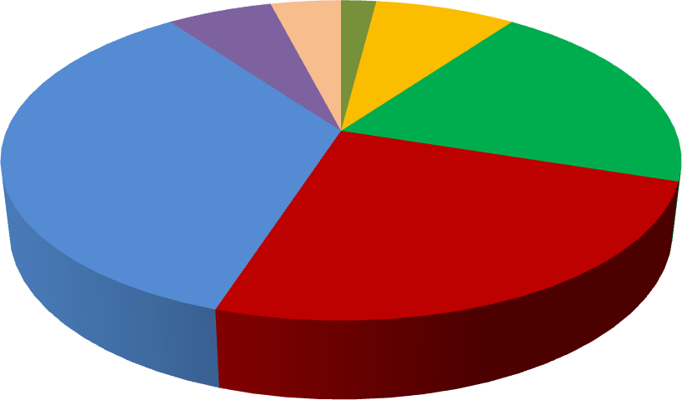

Design

Code Test

Implementation

25%

Customer Communication

Planning Analysis

35%

20%

8%

2%

4%

6%

**Effort Based Estimation**

Figure 4.1: Effort Based Estimation

**Description:**

* 1 (2% - Customer Communication)
* 2 (8% -Planning)
* 3 (20% -Analyzing)
* 4 (25% -Designing)
* 5 (35% -Coding)
* 6 (6% -Testing).
* 7 (4% -Implementation).

**Total Increment :(** week wise (Xth)**)**

|  |  |  |  |  |  |  |  |  |  |  |  |  |  |  |  |  |
| --- | --- | --- | --- | --- | --- | --- | --- | --- | --- | --- | --- | --- | --- | --- | --- | --- |
| Category | 1 | 2 | 3 | 4 | 5 | 6 | 7 | 8 | 9 | 10 | 11 | 12 | 13 | 14 | 15 | 16 |
| Analysis |  |  |  |  |  |  |  |  |  |  |  |  |  |  |  |  |
| Design |  |  |  |  |  |  |  |  |  |  |  |  |  |  |  |  |
| Code |  |  |  |  |  |  |  |  |  |  |  |  |  |  |  |  |
| Test |  |  |  |  |  |  |  |  |  |  |  |  |  |  |  |  |

## Figure 4.2: Project Schedule Chart

# 4.10 Cost Estimation

The approximation of the cost of a program is cost estimation. In this project, there are five factors to analyze and calculate the cost. Given bellow,

* + - * Personnel cost
      * Software cost
      * Hardware cost
      * Other cost

**Personnel cost**

* Number of working day 84
* Organization working hours per day = 6 hours
* Organization working hours per month=84*6= 504 hours hours

## Table-4. 7: Personal Cost

|  |  |  |  |
| --- | --- | --- | --- |
| **Type** | **No. of Members** |  | **Salary** |
| System Analyst | 1 |  | 40,000.00 |
| Coder, Tester &  Customer Communicator | 1 |  | 45,000.00 |
| **Total** | | **85,000.00** | |

### **4.2.7.1 Hardware Cost**

Cost of the computer that used to complete the project.

## Table-4. 8: Hardware cost

|  |  |  |  |  |
| --- | --- | --- | --- | --- |
| Name | Number | Price | Number *Price | Total |
| Computer | 1 | 25,000 | 25,000 | 25,000 |

Total Hardware Cost = 25,000.00 TK

### **4.2.7.2 Software Cost**

It is the cost of the software is which used in this project.

## Table-4. 9: Software Cost

|  |  |  |  |  |
| --- | --- | --- | --- | --- |
| **SL** | **Software** | **Number** | **Amount** | **Total** |
| 1 | OS (Windows 10) | 1 | Free | Free |
| 2 | MS Office 2013 | 1 | Free |
| 3 | VS code | 1 | Free |
| 4 | XAMP | 1 | Free |

### **4.2.7.3 Other Cost**

## Table-4. 10: Other cost

|  |  |
| --- | --- |
| **Name** | **Price** |
| Pen and paper | 300 Tk. |
| Mobile | 200 Tk. |
| Transport | 500 Tk. |
| **Total** | **1000 Tk.** |

**4.2.7.4 Accounts Table**

## Table-4. 11: Total cost

|  |  |
| --- | --- |
| **Particulars** | **TK** |
| Salary- | 85,000.00 /= |
| Total Hardware Cost –   * Computer | 25,000.00/= |
| Software Cost – | Free |
| Other Costs- | 1,000.00 /= |
| **Total cost** | **1,11,000.00 /=** |
|  |  |

# Chapter 5: Risk Engineering

# 5.1 Risk Analysis

Risk analysis and management is a series of works that help a system development team to understand and manage uncertainty. Many problems can arise while developing a system. A risk is a potential problem – it may happen may not. There are several steps to analyze and manage risks. The first step is risk identification. Next each risk is analyzed to determine the likelihood that it will occur and the damage that it will do if it does occur. Once this information is established risks is remarked. Finally, a plan is developed to manage those risks with high probability and impact.

**There are different stages of risk. They are:**

1. Risk identification: Risk identification is the process of detecting potential risks or hazards through data collection. A range of data collection and manipulation tools and techniques exists. The team is using both automated and manual techniques to collect data and begin to characterize potential risks to Web resources. Web crawling is one effective way to collect information about the state of Web pages and sites.
2. Risk classification: Risk classification is the process of developing a structured model to categorize risk and fitting observable risk attributes and events into the model. The team combines quantitative and qualitative methods to characterize.
3. Risk assessment: Risk assessment is the process of defining relevant risk scenarios or sequences of events that could result in damage or loss and the probability of these events. Many sources focus on risk assessment. Rosenthal describes the characteristics of a generic standard for risk assessment as "transparent, coherent, consistent, complete, comprehensive, impartial, uniform, balanced, defensible, sustainable, flexible, and accompanied by suitable and sufficient guidance.

# 5.2 Risk analysis

Risk analysis determines the potential impact of risk patterns or scenarios, the possible extent of loss, and the direct and indirect costs of recovery. This step identifies vulnerabilities, considers the willingness of the organization to accept risk given potential consequences, and develops mitigation responses.

1. **Risk management implementation:** defines policies, procedures, and mechanisms to manage and respond to identifiable risks. The implemented program should balance the value of assets and the direct and indirect costs of preventing or recovering from damage or loss.

There are different categories of risks that should be considered in any software project. The following categories of risks have been considered in this software project.

1. **Project risks:** These risks threaten the project plan. If these risks become real, it is likely that the project schedule will slip and that costs will increase. Project risks identify potential budgetary, schedule, personnel, resource, customer and requirement problems and their impact on the software project.
2. **Technical risks:** These risks threaten the quality and timeliness of the software to be produced. If a technical risk becomes a reality, implementation may become difficult or impossible. Technical risks identify potential design, implementation, interface, verification and maintenance problems. Moreover, specification ambiguity, technical uncertainty, technical obsolescence are also risk factors.
3. **Business risks:** These risks threaten the viability of the software to be built. The business risks can be market risks, building a system that no one really wants. Strategic risks, building a system that no longer fits into the overall business strategy for the company. Management risks, losing the support of senior management due to a change in focus or a change in people.

# 5.3 The RMMM Plan

* **Risk Mitigation:** Proactive planning for risk avoidance.
* **Risk Monitoring:** Assessing whether predicted risks occur or not, ensuring preventive steps are being properly applied, collect information for future risk analysis, attempt to determine which risks caused which problem.
* **Risk Management:** Actions to be taken in the event that mitigation steps have failed and the risk has become a live problem.
* **Type of Impact:** Catastrophic (1), Marginal (2), Tolerable (3), Critical (4).
* **Type of Probability:** very low (<10%), low (10–25%), moderate (25–50%), high (50–75%), very high (>75%).

**Project Risks:** Threaten the project plan. In my system, the bellow mentioned projects risks I needed manage.

## Table-5. 1: Project Risk (P01)

|  |  |
| --- | --- |
| **Project Risk (P01)** | |
| Name | Changes the requirements |
| Probability | Low (25%) |
| Impact | Marginal (2) |
| Description | Customer may change their requirements |
| Mitigation & Monitoring | Requirements are redefined by the company due to time or business needs. Meeting will be held with the company regularly. This ensures that the product we are producing solves a problem. |
| Management | Emergency meeting between both parties to identify new project requirements and goals. |
| Status | Not occur |

## Table-5. 2 Project Risk (P02)

|  |  |
| --- | --- |
| **Project Risk (P02)** | |
| Name | Poor Quality Documentation |
| Probability | Low (15%) |
| Impact | Catastrophic (1) |
| Description | Poor quality documentation of the members. |
| Mitigation & Monitoring | Meeting will be held routinely to offer documentation suggestions and topics. The progress on documentation will also have a Monitor in each meeting. |
| Management | The addition of new topics or removal of  Unnecessary topics into the documentation will assign to responsible person. |
| Status | Monitoring it. |

## Table-5. 3: Project Risk (P03)

|  |  |
| --- | --- |
| **Project Risk (P03)** | |
| Name | Lack of Development Experience. |
| Probability | Moderate (30%) |
| Impact | Catastrophic (1) |
| Description | Lack of developmental experience of the  Members. |
| Mitigation & Monitoring | Each member of the team should watch and  See areas where another team member may be weak. |
| Management | The members who have the most experience  In a particular area will be required to help for overcome problem arises for this risk. |
| Status | We have not encountered such issues yet |

## Table-5. 4: Project Risk (P04)

|  |  |
| --- | --- |
| **Project Risk (P04)** | |
| Name | Poor Comments in Code. |
| Probability | Low (15%) |
| Impact | Marginal (2) |
| Description | Code of the developed system is not up to the  Mark. |
| Mitigation & Monitoring | A formal written standard must be  Established to ensure quality of comments in all code. |
| Management | We should call a meeting with the development team to get rid of this problem and improve the quality of comments in Code. |
| Status | We are monitoring the issue. |

**Technical Risks:** threaten product quality and the timeliness of the schedule. As this is my practicum project, therefore these types of risks need to be take care of properly.

## Table-5.5: Technical Risk (TR01)

|  |  |
| --- | --- |
| **Technical Risk (TR01)** | |
| Name | Computer Crash |
| Probability | Moderate (25-40%) |
| Impact | Catastrophic (1) |
| Description | Computer may crash due to several reasons. |
| Mitigation & Monitoring | We should take proper follow up of computers. We also take regular data backup every day, We can use IPS to stop  Unexpected shutdown. |
| Management | If our computer has been crashed then we will restore backup. |
| Status | We have not encountered such issue yet |

## Table-5.6: Technical Risk (TR02)

|  |  |
| --- | --- |
| **Technical Risk (TR02)** | |
| Name | Technology Doesn‘t Meet Specifications. |
| Probability | Low (25%) |
| Impact | Catastrophic (1) |
| Description | Customer doesn‘t have the technology to their desired specification. |
| Mitigation & Monitoring | That ensures that the product we are producing and the specifications of the customer are equivalent. |
| Management | The customer should be immediately notified and whatever steps necessary to rectify this problem should be done. Preferably a meeting should be held between the development team and the customer to  discuss at length this issue. |
| Status | We have not encountered such issue yet |

## Table-5.6: Technical Risk (TR03)

|  |  |
| --- | --- |
| **Technical Risk (TR03)** | |
| Name | Poor Training Skill in Team Members. |
| Probability | Moderate (30%) |
| Impact | Catastrophic (1) |
| Description | Poor Training Skill in Team Members to  Train the Client. |
| Mitigation & Monitoring | The training team should have a clear knowledge about the entire functionality of the software. System analyst need to ensure and monitor it while training session start. |
| Management | We should arrange a meeting with the train team and come to a point to solve this problem |
| Status | We have not encountered such issue yet |

**Business Risk:** Threaten the viability of the software to be built (market risks, strategic risks, management risks, budget risks). As I am developing it as my practicum project by myself, classic business risks won‘t be encountered here. The Probability of all type of Business Risks is therefore, determined as Low.

## Table-5.7: Business Risk (B01)

|  |  |
| --- | --- |
| **Business Risk (B01)** | |
| Name | Insufficient Budget |
| Probability | Low (10%) |
| Impact | Marginal (2) |
| Description | If the budget is low project may not complete. |
| Mitigation & Monitoring | The project needs streaming server that is costly to set-up. We find several alternative streaming services to reduce the budget risk. |
| Management | Refinement in project goal. A new plan for regulate the budget. |
| Status | Not encountered |

## Table-5.8: Business Risk (B02)

|  |  |
| --- | --- |
| **Business Risk (B02)** | |
| Name | End Users Accept System |
| Probability | Low (10%) |
| Impact | Critical (4) |
| Description | The system fails to gain user‘s faith. |
| Mitigation & Monitoring | In order to prevent this from happening, the software will develop with the end user in mind. The user-interface will design in a way to make use of the program convenient and pleasurable. |
| Management | Training the users to familiarize them with the new system. Releasing patches/bug fixes for greater user satisfaction. |
| Status | The risk has not been arisen yet. |

## Table-5.9: Business Risk (B03)

|  |  |
| --- | --- |
| **Business Risk (B03)** | |
| Name | Not pay the installment of Software Cost. |
| Probability | Very Low (05%) |
| Impact | Catastrophic (1) |
| Description | Customer doesn‘t pay for the installment of  Software Cost. |
| Mitigation & Monitoring | We should make a good communication between customers and ensure that the entire  Installment will be completed. |
| Management | The only course of action available would be find out the reason and come in a solution. |
| Status | Not encountered. |

## Table-5.10: Business Risk (B04)

|  |  |
| --- | --- |
| **Business Risk (B04)** | |
| Name | Late delivery of the project |
| Probability | Very Low (05%) |
| Impact | Catastrophic (1) |
| Description | The project may take more time to complete what was estimated. |
| Mitigation & Monitoring | Steps have been taken to ensure a timely delivery by determining the scope of project. |
| Management | The only course of action available would be to request an extension to the deadline from customer. |
| Status | My project is completed in time. |

# Chapter 6: Analysis Modeling

Analysis modeling uses a combination of text and diagrammatic forms to depict requirements for data, function, and behavior in a way that is relatively easy to understand, and more important, straightforward to review for correctness, completeness and consistency. This section presents resources for conventional and object-oriented analysis (OOA) methods as well as resources for UML.

# 6.1 Analysis Modeling

Objectives of analysis model

* + - Domain Analysis
    - Describe what the client requires
    - Establish a basis for the creation of a software design
    - Define a set of requirements that can be validated once the software is built.

# 6.2 Activity Diagram

Activity diagrams are graphical representations of workflows of stepwise activities and actions with support for choice, iteration and concurrency. In the Unified Modeling Language, activity diagrams are intended to model both computational and organizational processes.

## 6.2.1 Activity diagram for Admin

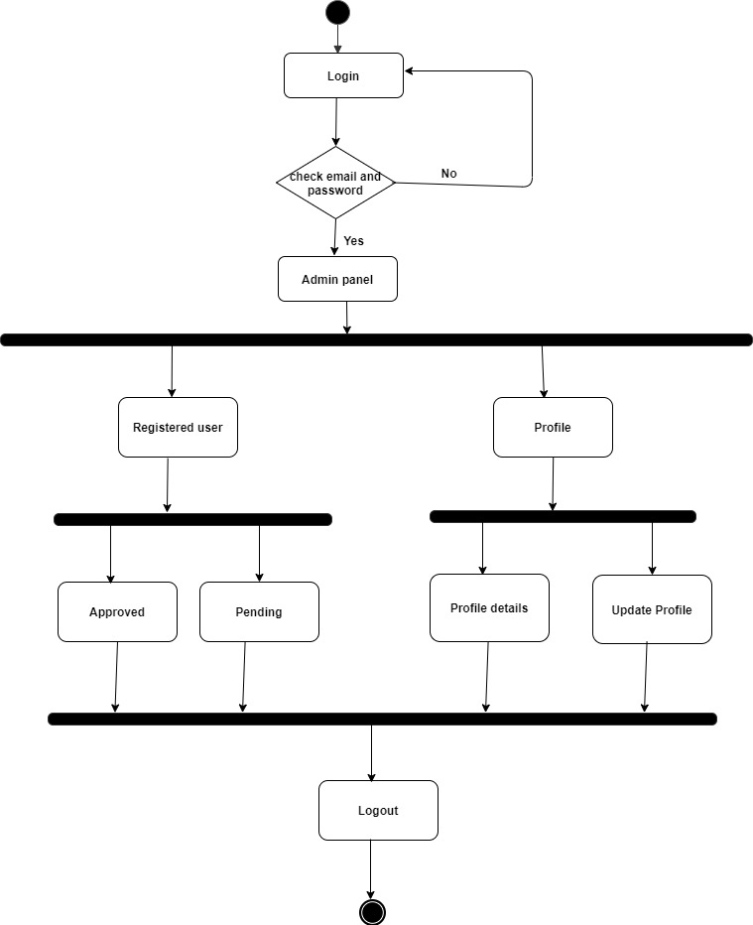

## Figure 6.1: Activity diagram for Admin

## 6.2.2 Activity diagram for Author

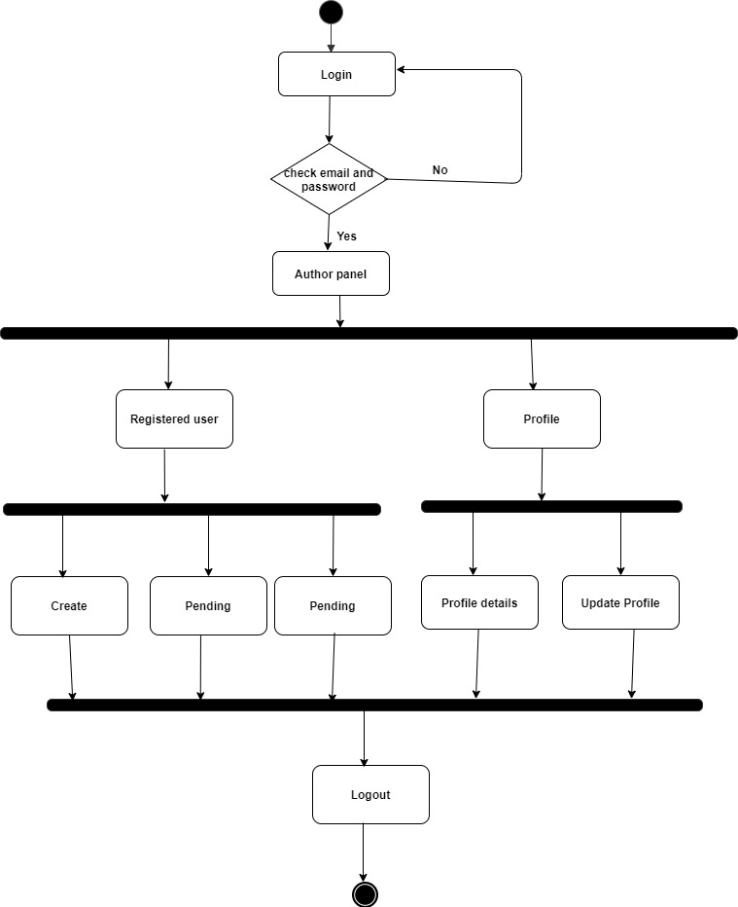

## Figure 6.2: Activity diagram for Admin

## 6.2.3 Activity diagram for Publisher

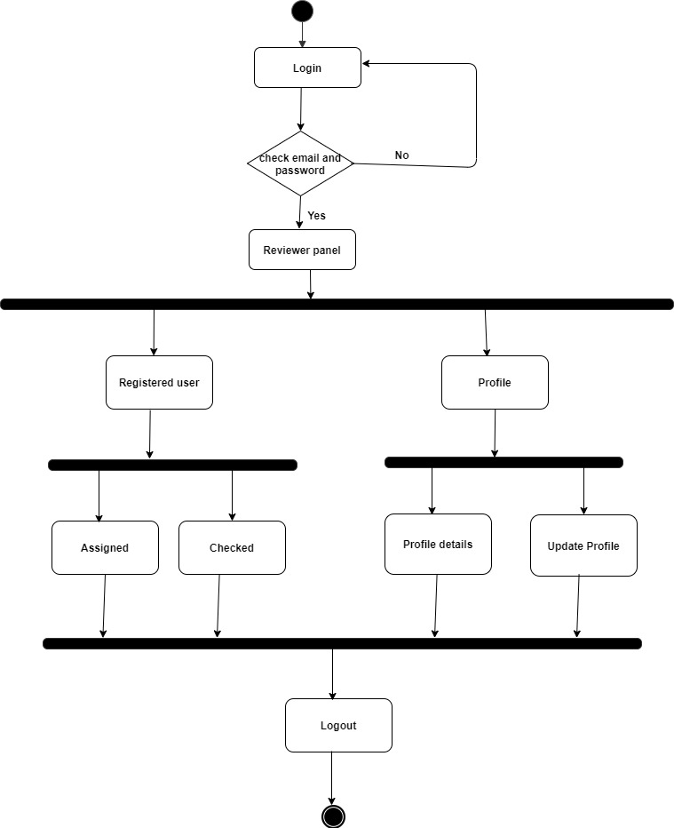

## Figure 6.3: Activity diagram for Admin

## 6.2.4 Activity diagram for Reviewer



## Figure 6.4: Activity diagram for Admin

# 6.3 Swim lane Diagram

Swim lane is a visual element used in process flow diagrams, or flowcharts that visually distinguishes job sharing and responsibilities for sub-processes of a business process. Swim lanes may be arranged either horizontally or vertically. In the accompanying example, the swim lanes are named Admin, Faculty, and System timetable and are arranged vertically.

## 6.3.1 Swim Lane Diagram for Journal Management System

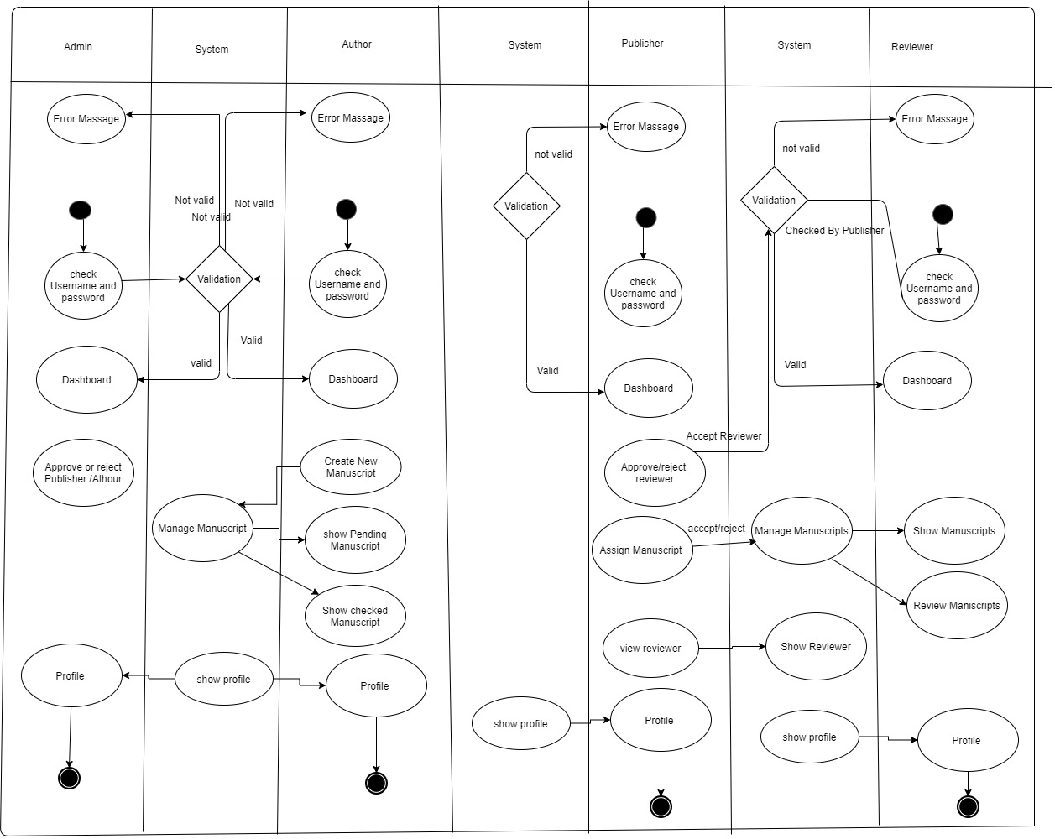

## Figure 6.5: Swim Lane diagram for Journal Management System

# 6.4 Entity Relationship Diagram

An entity-relationship diagram (ERD) is a type of representation of objects or concepts within relationship to one another. While useful for organizing data that can be represented by a relational structure, an entity- relationship diagram can't sufficiently represent semi-structured or unstructured data, and an ERD is unlikely to be helpful on its own in integrating data into a pre-existing information system. Three main components of an ERD are the entities, which are objects or concepts that can have data stored about them, the relationship between those entities, and the cardinality which defines that relationship in terms of numbers.

## ER Diagram

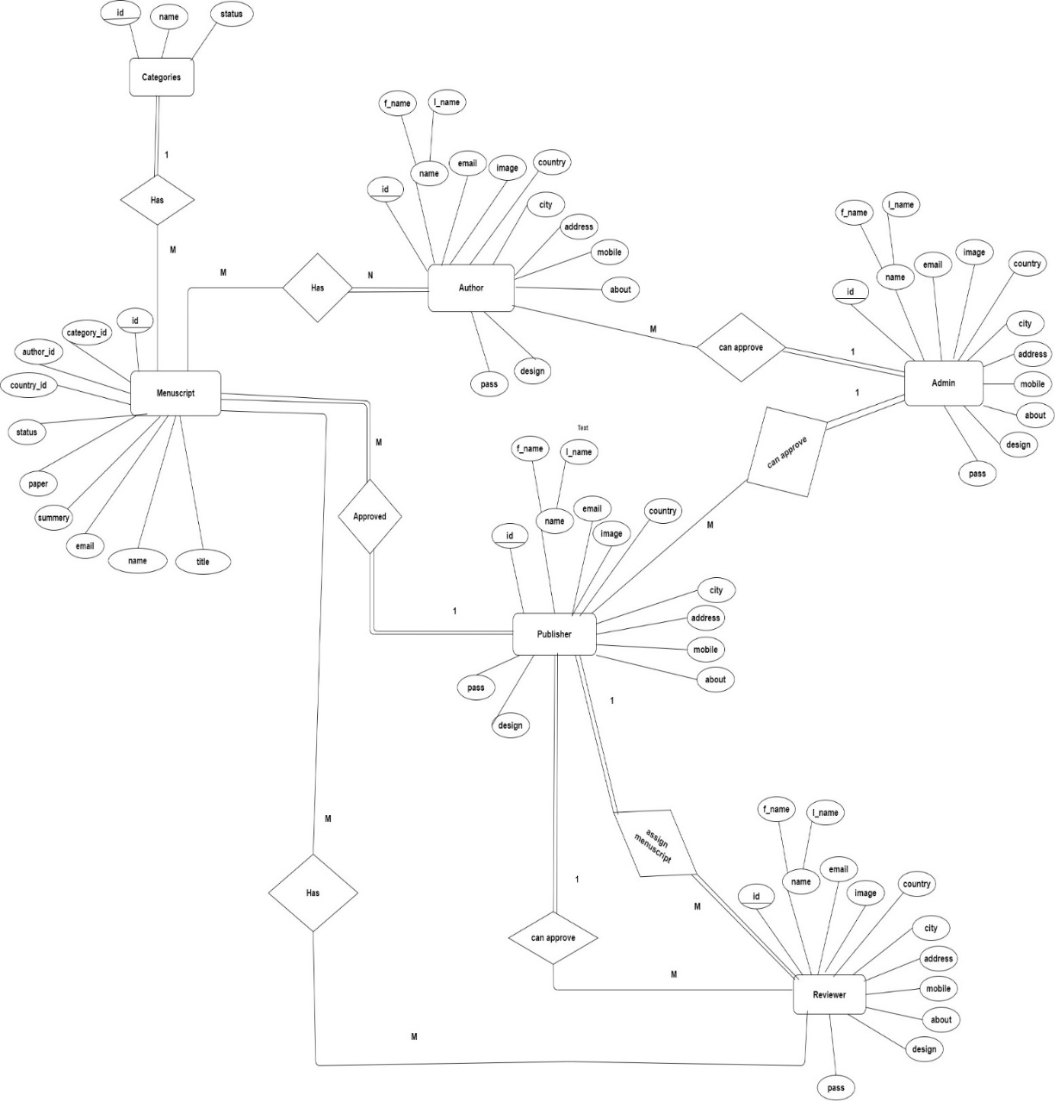

## Figure 6.6: ER Diagram of Journal Management System

# 6.5 Data Flow Diagram

A data flow diagram (DFD) is a graphical representation of the "flow" of data through an information system, modeling its process aspects. A DFD is often used as a preliminary step to create an overview of the system, which can later be elaborated DFDs can also, be used for the visualization of data processing.

A DFD shows what kind of information will be input to and output from the system, where the data will come from and go to, and where the data will be stored. It does not show information about the timing of process or information about whether processes will operate in sequence or in parallel.

## 6.5.1: Context Level Diagram

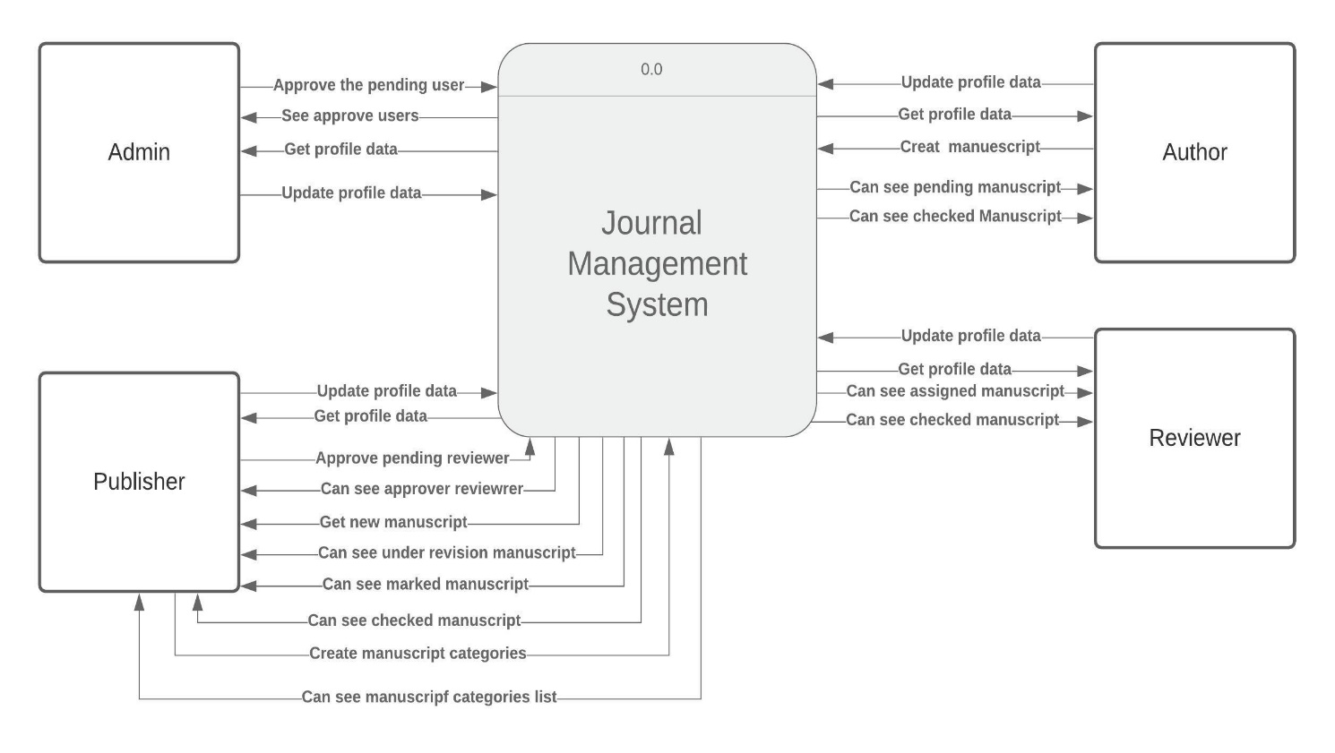

## Figure 6.7: Context Level 0 Diagram of Journal Management System

## 6.5.2: Level 1 DFD

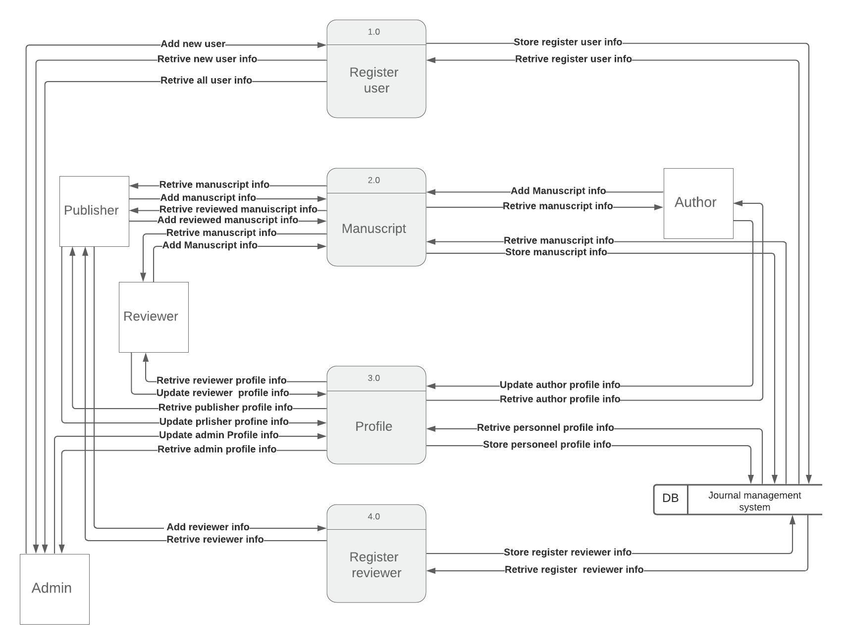

## Figure 6.8: Level 1 for System

## 6.5.3: Level 2 DFD Process 1

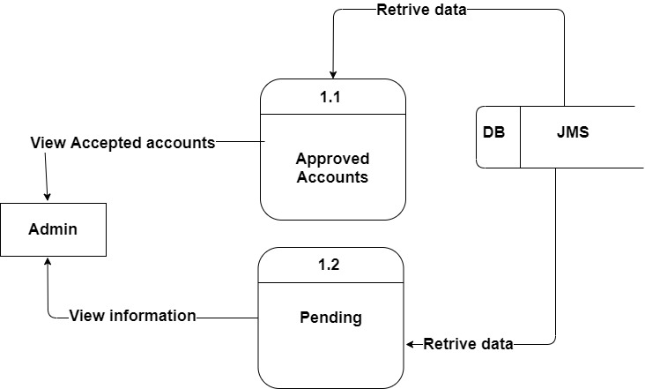

## Figure 6.9: Level 2.

## 6.5.4:Level 2 DFD Process 2

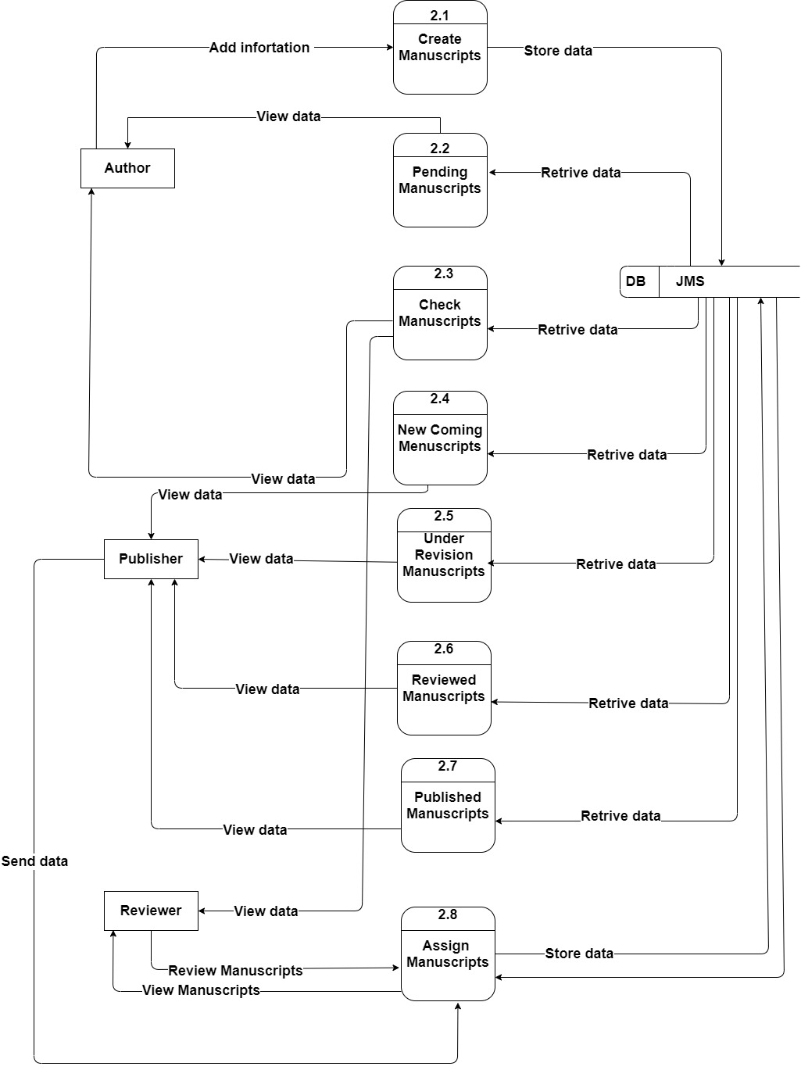

## Figure 6.10: Level 2.2

## 6.5.5: Level 2 DFD Process 3

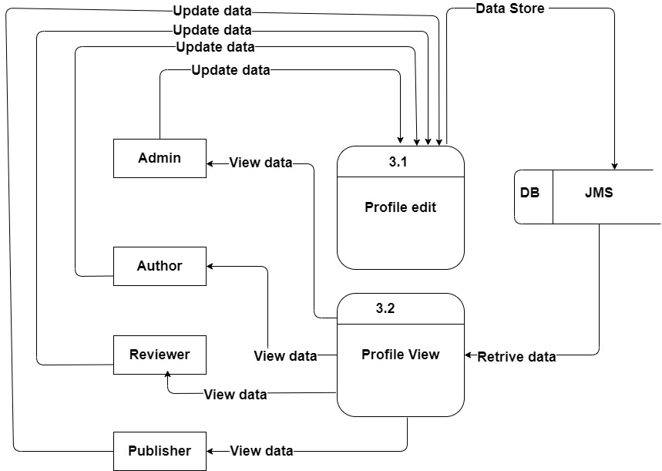

## Figure 6.11: Level 2.3

## 6.5.6: Level 2 DFD Process 4

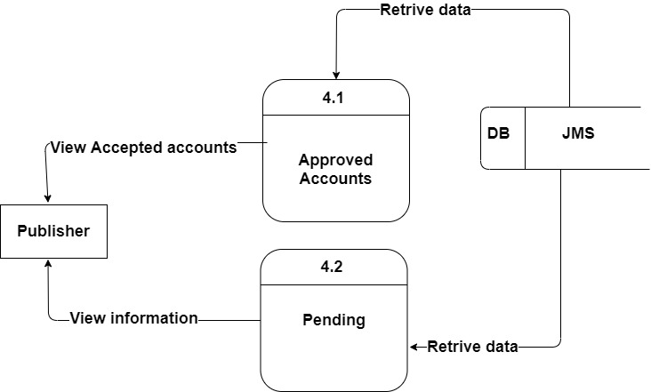

## Figure 6.12: Level 2.4

## 6.5.7: Level 3 DFD Process 1.2

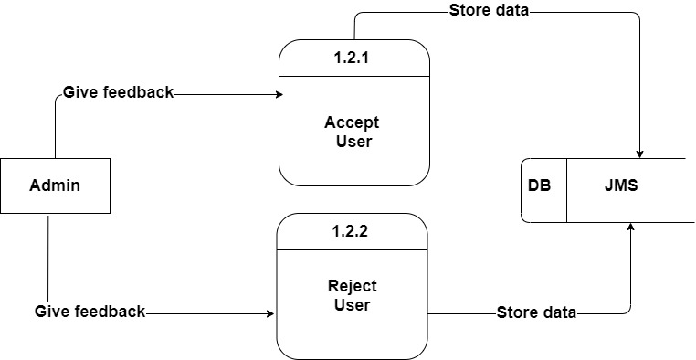

## Figure 6.13: Level 3, Process 1.2

## 6.5.8: Level 3 DFD Process 2.6

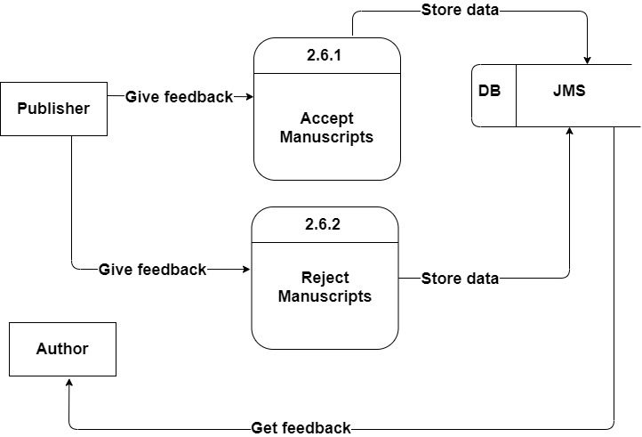

## Figure 6.14: Level 3, Process 2.6

## 6.5.9: Level 3 DFD Process 4.2

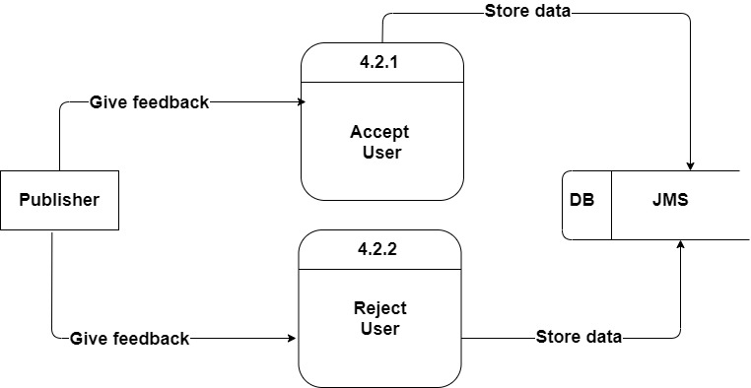

## Figure 6.15: Level 3, Process 4.2

# 

# Chapter 7: Design

# 7.1 Database Design

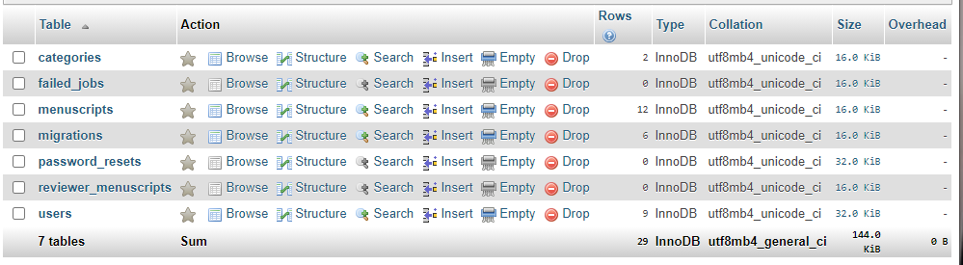

Database Tables

## Figure 7.1: Database Tables

**User table:**

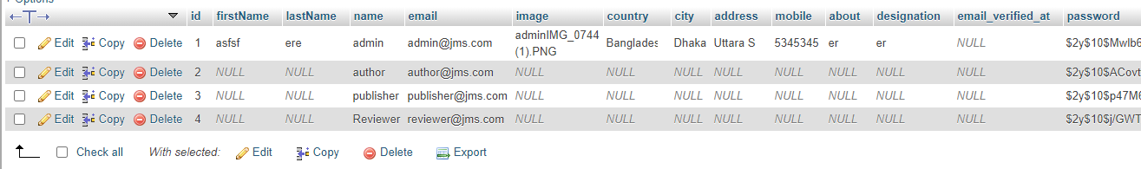

## Figure 7.2: User Table

**Manuscript table:**

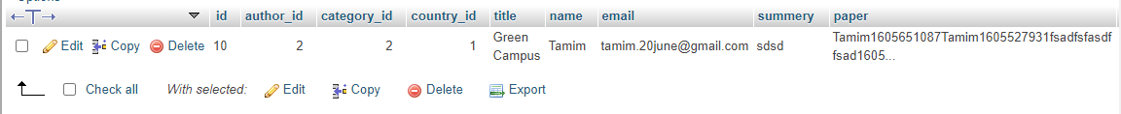

## Figure 7.3: Manuscript Table

**Categories Table:**

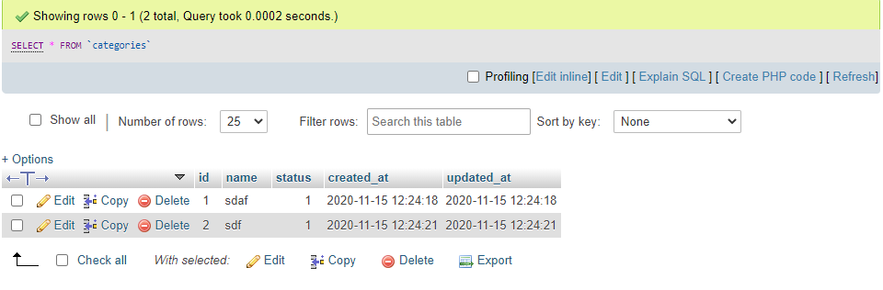

## Figure 7.4: Category Table

# 7.2 Interface Design

**Front Page:**

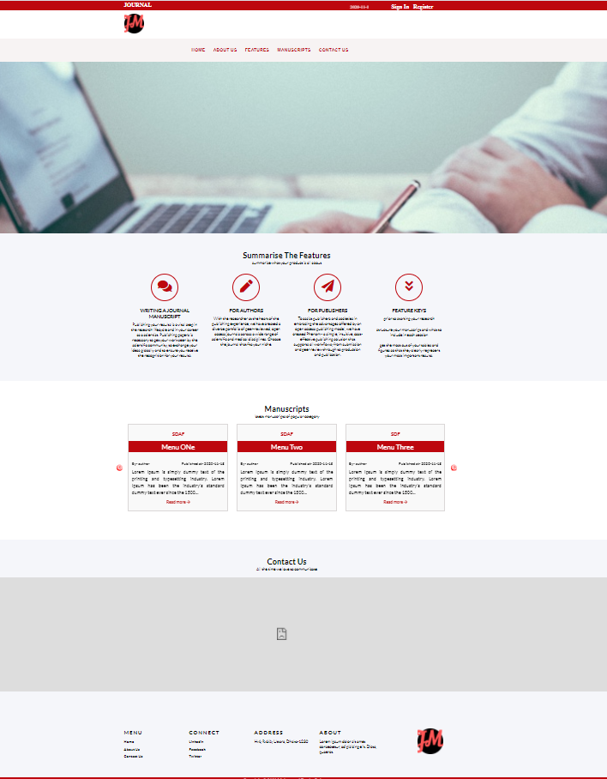

## Figure 7.5: Interface

**Registration Page:**

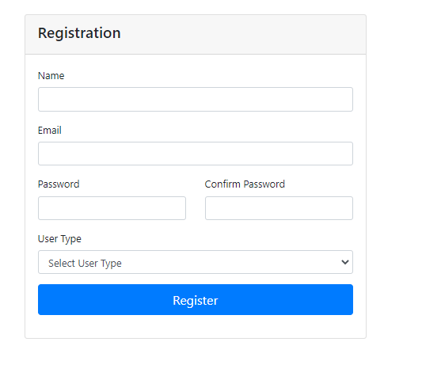

## Figure 7.6: Registration Page

**Profile Update Page:**

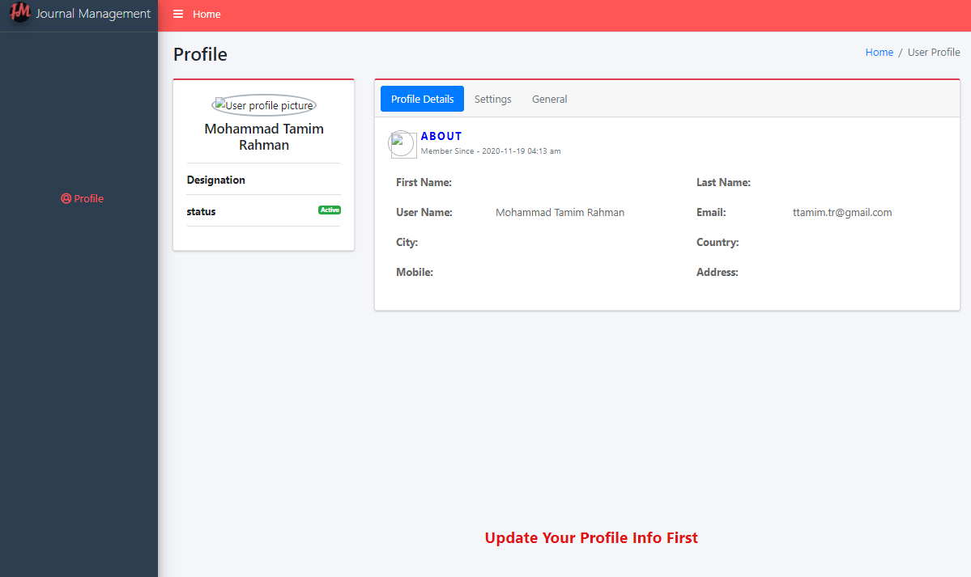

## Figure 7.6: Registration Page

**Admin Page:**

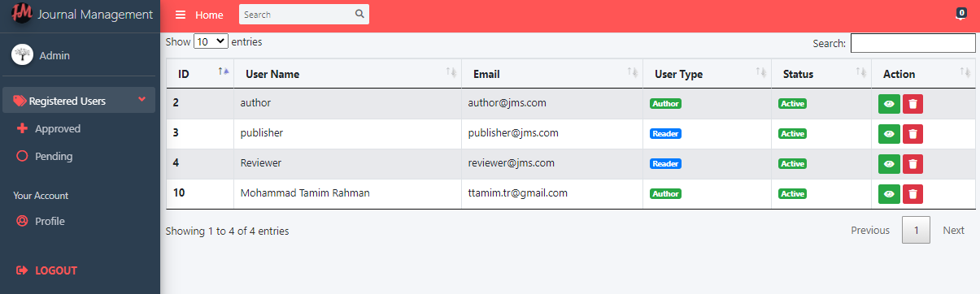

## Figure 7.7: Admin Page

**Create Manuscript Page:**

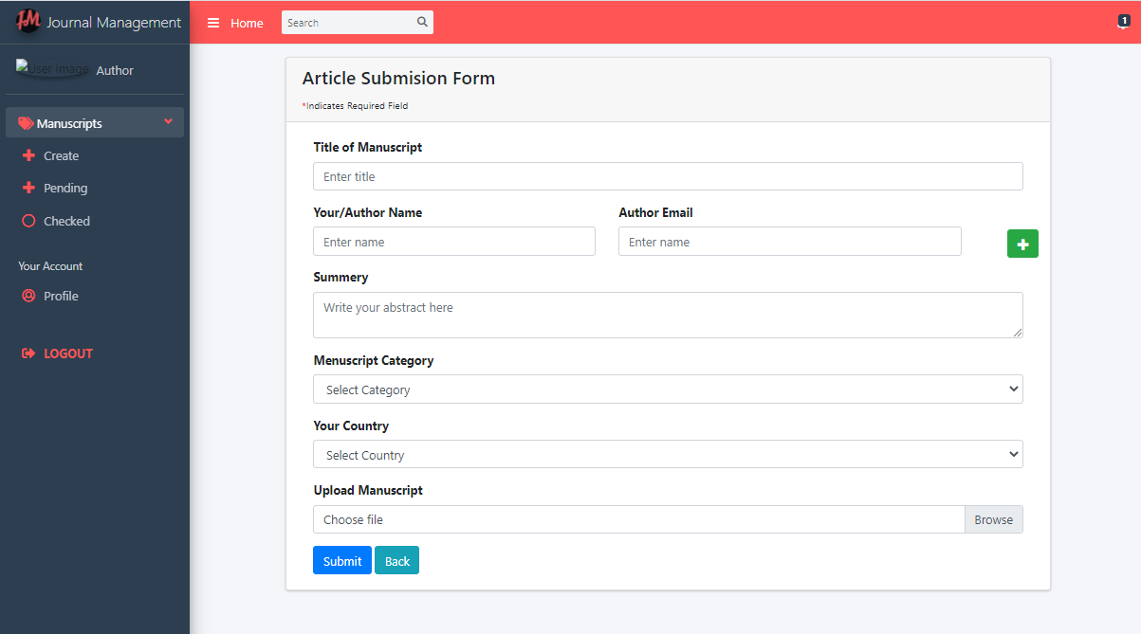

## Figure 7.8: Create Manuscript Page

Publisher Page:

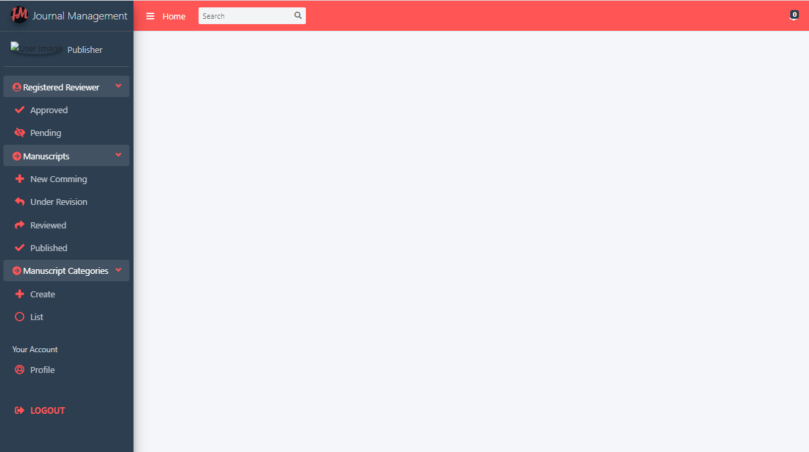

## Figure 7.9: Publisher Page

**Reviewer Page:**

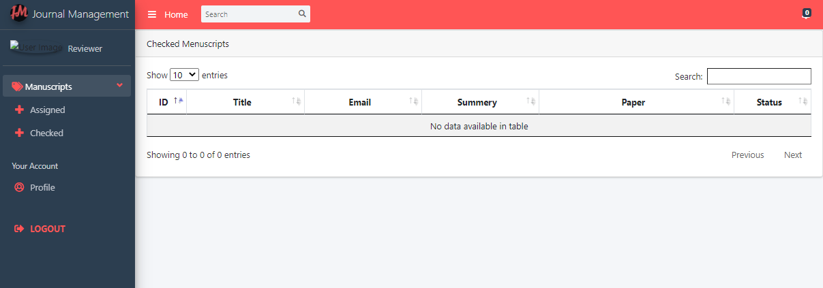

## Figure 7.10: Reviewer Page

# 

# Chapter 8: System Testing

# 8.1 System Testing

Software testing is the process of evaluation a software item to detect differences between given input and expected output also, to assess the features of a software item. Testing assesses the quality of the product. Software testing is a process that should be done during the development process. In other words, software testing is a verification and validation process.

**Verification:** Verification is the process to make sure the product satisfies the conditions imposed at the start of the development phase. In other words, to make sure the product behaves the way we want it to.

**Validation:** Validation is the process to make sure the product satisfies the specified requirements at the end of the development phase. In other words, to make sure the product is built as per customer requirements.

The objectives of software testing are:

Testing is a process of executing a program with the intent of finding an error.

A good test case is one that has a high probability of finding an as-yet-undiscovered error.

A successful test is one that uncovers an as-yet-undiscovered error.

The design of tests for software can be challenging as the initial design of the product itself. Software can be tested in one of two ways:

Knowing the specified function that the software has been designed to perform, tests can be conducted that demonstrate each function fully while at the same time searching for errors in each function. This approach is known as black-box testing.

Knowing the internal workings of software, tests can be conducted to ensure that internal operations are performed according to specifications and all internal components have been adequately exercised. This approach is known as white-box testing.

## 8.1.1 Software Testing Strategy

A strategy for software testing integrates software test case design methods into a well- planned series of steps that result in the successful construction of a software. The strategy provides a road map that describes the steps to be conducted as part of testing.

Testing strategy that will be followed in this software project –

* Unit testing
* Integration testing
* Validation testing

The first step in software testing is unit testing. Unit testing concentrates on each unit of the software as implemented in source code. Unit testing focuses on each component individually. The unit test is white-box oriented. Thus, unit testing of this library software will be done after completion of every module or component.

The next step is integration testing. Integration testing is a systematic technique for constructing the program structure while at the same time conducting tests to uncover errors associated with interfacing. The objective of integration testing is to take unit tested components and build a program structure that has been dictated by design.

The integration testing strategy that has been chosen for this project is top down testing. Black-box testing method is the most prevalent for integration testing. Top down integration strategy will be used to perform integration testing. Top down integration will be done by breadth-first manner. Breadth-first integration incorporates all components directly subordinate at each level, moving across the structure horizontally.

After the software has been integrated, a set of high order tests am conducted. Hence, the validation criteria that have been mentioned in requirements engineering should be tested. Validation testing provides final assurance that software meets all functional, behavioral and performance requirements. The black-box testing method is exclusively used in validation.

# 8.2 System Testing Methodology

**Black-box Testing**

Black-box testing which is also known as behavioral testing focuses on the functional requirements of the software. It enables the software engineer to derive sets of input conditions that will fully exercise all functional requirements for a program. Black-box testing method will be applied to test the modules of OEMS.

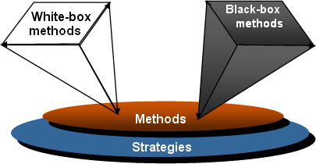

Figure 8.1: Black box and White box testing

**White-box Testing**

White-box testing, which also known as *glass-box testing*, is a test case design method that uses the control structure of the procedural design to derived test cases. Using white-box testing methods, software engineer can derive test cases that,

1. Guarantee that all independent paths within a module have been exercised at least once
2. Exercise all logical decisions on their true and false sides
3. Execute all loops at their boundaries and within their operational bounds
4. Exercise internal data structures to ensure their validity.

The modules that contain some complex calculations or decision-making code such as check the availability of the library item will be tested using white-box method.

## Table-8. 1: Testing Scenario No-1

|  |  |
| --- | --- |
| Scenario | Login testing scenario of my system |
| Input’s | Email and password for login |
| Desired Output’s | When enter Email and password then get access level that defined. |
| Actual Output’s | For login, my system works properly. |
| Verdict | Getting result from desired outputs and actual |
| outputs decided this system is successful for |
| Login |

## Table-8.2: Testing Scenario No-2

|  |  |
| --- | --- |
| Scenario | User approve or reject scenario of my system. |
| Input’s | Admin can take action |
| Desired Output’s | Admin can approve or reject user. |
| Actual Output’s | I check this process and get actual outputs |
| Verdict | My system has worked Successfully. |
|  |

## Table-8.3: Testing Scenario No-3

|  |  |
| --- | --- |
| Scenario | Author can crate manuscript |
| Input’s | Author give information to upload a manuscript. |
| Desired Output’s | Authors information uploaded successfully |
| Actual Output’s | I check this process and get actual outputs |
| Verdict | My system has worked correctly and successfully. |

## Table-8.4: Testing Scenario No-4

|  |  |
| --- | --- |
| Scenario | Publisher can assign manuscript |
| Input’s | After getting the manuscript publisher assign manuscript to reviewer |
| Desired Output’s | Publisher assign is successfully and reviewer can see. |
| Actual Output’s | My desired output access to actual and practical output. |
| Verdict | My system has worked correctly and successfully. |

## Table-8.5: Testing Scenario No-5

|  |  |
| --- | --- |
| Scenario | Reviewer can review manuscript |
| Input’s | After getting the manuscript reviewer reviewed the manuscript. |
| Desired Output’s | Reviewer can review the manuscript and able to see it in the reviewed section. |
| Actual Output’s | My desired output access to actual and practical output. |
| Verdict | My system has worked correctly and successfully. |

Table-8.6: Testing Scenario No-6

|  |  |
| --- | --- |
| Scenario | Publisher can publish or reject manuscript |
| Input’s | After getting the manuscript from reviewer publisher polisher or reject manuscript. |
| Desired Output’s | Publisher publish or reject it successfully. |
| Actual Output’s | I check this process and get actual outputs |
| Verdict | My system has worked correctly and successfully. |

# 

# Chapter 9: Conclusion

# 9.1 Preface

Today is the age of modern science and information and online communication, which is critical to development of more effective operational and management process. To provide better and uninterrupted services to the employee of Uttara Tech Info a group of Software specialist working together to keep the service all time. I was fortunate and blessed to get this lucky break to work some of these efficient hard-working friendly engineers. My earnest thanks, gratitude and salutations to these wonderful people from the deep down inside my heart.

## 9.1.1 Practicum and Its Value

In your career development as with most life issues there is direct relationship between effort and reward. To me, practicum can be as a transition from engineering college study life to a real-world workplace through hands on experience of engineering practices.

The four years of undergraduate engineering studies gives a student theoretical and practical knowledge. Using that knowledge and observing live operational system, the practicum program clarifies those subjects ‘matters to another level blessed with practical working skills. Considering this fact, it gives us an immense pleasure to say that my practicum was a successful event.

Practical work experience doesn’t have any other alternatives. Before getting into the job student should have a real-world work experiences in a major field of study. Now a day‘s recruiter no longer considers just high grades, good communication skill, part time work experiences. They highly consider the work experiences of an applicant. Students with better work experiences are getting the better job opportunities.

Uttara Tech Info gave me the opportunity of working in a professional working environment. During the internship period, I have tried my level best to make my system efficient. I followed the lessons, methods, tools and techniques that I have learned during my study period at IUBAT. Successful software development is a blend of standard development practices, proper theoretical knowledge and the developer‘s creativity.

Student of College of Engineering and Technology (CEAT) at IUBAT go for this practicum program carrying 6 credit hours weight, which goes for a semester long and usually after the completion of the course work.

# 9.2 Limitations

One of the limitations of this project is constraints of time. The time that is assigned for this project is very short. After applying the software engineering procedures, it is very difficult to develop the complete software within this short time. For this reason, the scope of the project has become short. In this short time, it is very difficult to understand the problem, collect information and construction the project. For this reason, the scope of the project has become short. Moreover, many problems have been arisen in the data collection for the software.

# 9.3 Future Plan

By this limited time of internship, one can develop the core features of this system but in future, it can be possible to add more features:

* + 1. Publisher profile will updated with many other information
    2. Email verification.
    3. Payment Method for premium paper

# **9.4 Conclusion**:

The biggest experience working at Lion Tech is indeed being a part of designing and implementing software. I have learnt a lot of new things which was so much unknown to me. I have also learnt some technical issues which help to do better in future life. The following indicator will indicate some of my technical issue which I have learnt and implemented from this project.

* The designing strategy of a web-based project.
* The analyzing strategy of a web-based project.
* New environment of programming languages.
* How to coding and designing by PHP, HTML 5 and CSS 3, Bootstrap 4, JavaScript.

# 

#### References

[1] Kendall, E. &amp; Kendall (1999), System Analysis and Design. 4th Ed. New Delhi: Prentice Hall.

[2] Pressman, Roger S. (2004). Software Engineering: A Practitioner’s Approach. 5th ed. Boston: McGraw Hill.

[3] Silberschattz, Abraham, Korth, Henry F.Sudarshan S. (2002). Database System Concepts.

4th ed. Boston: McGraw Hill.

[4] Wikipedia contributors, (2019, August 13). Software testing. In Wikipedia, the Free

Encyclopedia. Retrieved 17:08, August 17, 2019, from https://en.wikipedia.org/w/index.php?title=Software_testing&amp;oldid=910709415

[5] BOT contributors (node). Software Engineering –Function-Oriented Metrics. Retrieved from https://1000sourcecodes.com/2012/05/software-engineering-function-oriented.html